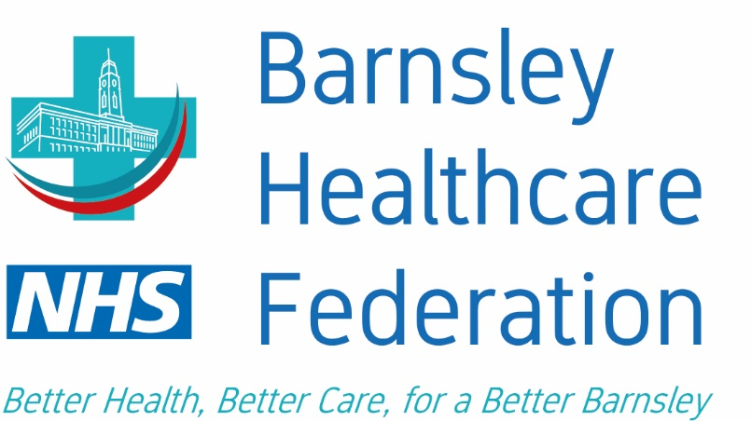
SOP for GPNs/HCAs/NAs visits to shielded Patients Own Home

BHF COVID-19 Community Visits Standard Operating Procedure GPNS for shielding patients

Standard Operating Procedure

This document describes the standard operating procedure (SOP) for GPN teams to visit patients within their own home with low risk and who may be shielding and cannot attend surgery.

Before visiting any patients

- Contact the patient by telephone prior to the visit to determine whether they are symptomatic of COVID-19 symptoms.
- Does the patient or anyone living within the property have symptoms?
- A new persistent cough.

and/or

- A temperature above 37.8; or
- Is a confirmed Covid-19 case

If YES to any of the above - Provide the patient with self-isolation advice (DO NOT VISIT/Refer to GP/ANP)

If this NO to all the above - The clinician may continue to the visit for essential care only.

Arrival at the home and maintaining a safe environment

If on arrival at the person’s accommodation it becomes apparent that the service users condition has deteriorated and/or requires immediate treatment or clinical assessment (outside the scope of the GPN/HCA/NA) you should dial NHS 111 or 999 for conveyance to the acute hospital informing them that the service user is suspected as having COVID-19.

Equipment

The GPN/HCA teams should take only the minimum of equipment into the house.
Ideally use single use equipment and dispose of as clinical waste.

If equipment is to be re-used, then it should be double bagged in to sealed bags before removal from the property and decontaminated with alcohol or clinelle wipes and left to dry at the staff member’s base. Ideally, in a dirty utility, where available.

Staff clothing

Uniforms/clothing worn for work must keep with bare below the elbow instructions.

Hair

Must be tied back securely and off the neck and collar and jewellery, pens and lanyards must be removed before entering a patients’ home.

Personalised protective equipment (PPE)

1. Apron;
2. Gloves;
3. Fluid repellent surgical mask; and
4. Eye protection, such as single use goggles or full-face visors (should be risk assessed and worn if there is a contamination risk from splashes or droplets).

Follow Guidance for PPE Non AGP.

Hand hygiene

This is essential before and after all patient contact, removal of PPE and decontamination of the environment. See Full PPE guidance.

Closing the visit

On completion of the visit and prior to removing PPE, staff should ensure the service user understands their responsibilities for shielding including respiratory and cough hygiene and avoiding contact with others until informed otherwise.

Waste

The guidance states that after 72 hours the waste can be disposed of as general waste: this is to ensure that any bacteria will have died before the waste is collected by the authority. Staff should ask the householder when their collection day is:

- If it is over 72 hours until their waste will be collected then it would appear reasonable to place the waste, double bagged, in household waste bags directly into the general waste bin.
- If the householder advises that their general waste collection will be in less than 72 hours, then this should be placed in a suitable container until after the collection and then it can go into their general waste bin. The service user should be completing this process with any personal waste that they may generate.

Under no circumstances should staff place orange waste bags into service users' bins.

Decontamination

The team should take as little as possible into the home and use as many single patient use items as possible.

Any reusable equipment must be double bagged and transported back to base for decontamination with alcohol or clinelle wipe and allowed to dry.

Decontaminate the following items:

Medical devices taken into the property i.e. thermometer/ saturation probe/ stethoscope / blood pressure machine – sphygmomanometer

Documentation

Staff must document on SystmOne as usual.

