Developmental Red Flags – When to Refer?

At all ages:
- OFC > 98 or < 0.4 or rapid change in OFC
- Regression
- Squint
- Parental concern

If Red Flag’s present refer to Community Paediatrics

6 weeks
- No visual fixation or following - always refer
- Failure to respond to sound
- Asymmetrical neonatal reflexes
- Excessive head leg
- Failure to smile

6-8 months
- Hand preference, fisting,
- Squint, not reaching
- Persistence of primitive reflexes
- Floppy and poor head control
- Lack social response/ vocalisation

12 months
- Unable to sit or bear weight
- Absence of saving reactions
- Persistence of hand regard
- Poor communication
- No babble

18 months
- Not walking
- Inability to understand simple commands
- No pointing
- No words
- No pincer grip
- Casting (throwing) and mouthing

2 years
- Not running
- 2 step command
- 2-3 words together

Bilingual – only have expressive delay 3-6 months

Top tips:
- Speech and language development is the most variable domain and sensitive to environmental factors e.g. maternal depression
- If there is delay in more than one domain – gross motor, fine motor and vision, speech and language, social development – it is more likely to be significant.

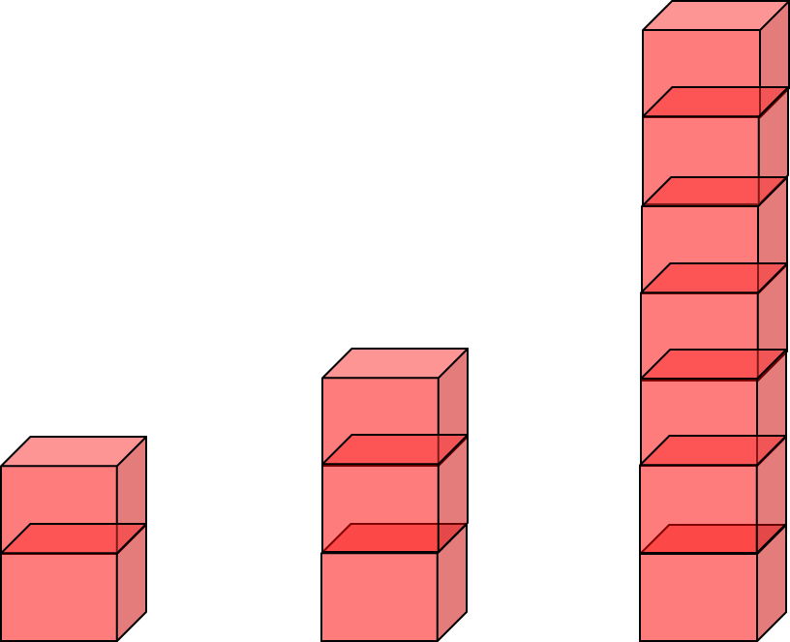
3years 4 years 5 years

12m 15m 24m 24m

18 months
2 years
3 years

3.5
4 years
5 years

6 years

Median ages for development of skills – bricks and drawing NB pencil grasp by 3 years

