

***Breast Pain Referral Form***

***14 day Symptomatic Pathway***

**Female patients with breast pain alone** (no palpable abnormality or any other red flag symptoms)

For the Primary Care management algorithm for breast pain please see appendix A

Please aim to not refer until primary care management has been attempted.

**Patient Details:**

|  |  |  |  |
| --- | --- | --- | --- |
| **Patient Name** | ${firstname} ${surname} | | |
| **Address** | ${patientAddress}  ${postcode} | | |
| **DOB** | ${dob} | **NHS No.** | ${nhsNumber} |
| **Home Tel. No.** | ${home} | **Gender** | ${gender} |
| **Mobile Tel. No.** | ${mobile} | **Ethnicity** | ${ethnicity} |
| **Preferred Tel. No.** | ${preferredNumber} | **Email Address** | ${email} |
| **Main Spoken Language** | ${language} | **Interpreter needed?** | Yes  No |
| **Transport needed?** | ${transportNeeded} | **Patient agrees to telephone message being left?** | Yes  No |
| **Communication requirements** | Hard of hearing:  Visually impaired:  Learning/mental difficulties: | | |
| **Date of Decision to Refer** | ${createdDate} | | |

**Registered GP Details:**

|  |  |  |  |
| --- | --- | --- | --- |
| **Practice Name** | ${practiceName} | | |
| **Registered GP** | ${usualName} | **Usual GP / Referring GP** | ${referringClinical} |
| **Registered GP**  **Address** | ${practiceAddress} | | |
| **Tel No.** | ${main} | **Fax No.** | ${fax} |
| **Email** | ${gpEmail} | **Practice Code** | ${practiceCode} |

|  |
| --- |
| **REFERRAL CRITERIA** |
| Patient has breast pain only  Mastalgia Pathway has been Followed (see appendix A).  The patient been given the Breast Pain information leaflet treatment |
| **EXCLUSION CRITERIA**  **\*\* if any of the below are applicable, please refer the patient via the Fast Track Referral – 2 week wait** |
| Patient has a palpable lump/ thickening/ skin changes/ nipple discharge |
| Patient has previous history of breast cancer |
| Patient is pregnant or breast feeding |
| Patient is undergoing gender reassignment treatment |
| Patient has breast implants |
| **EXAMINATION** |

*Please indicate the site of breast pain* Clinical findings, additional text:

${clinicalFindings}

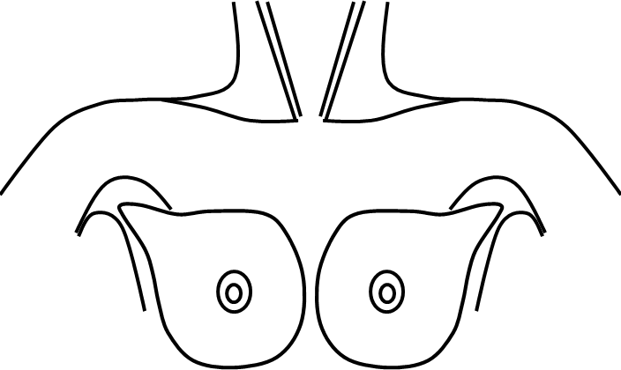

|  |
| --- |
| Please include the date and location of any previous breast imagining if available:  ${mammographyG} |
| *Please inform patients that this is a community breast pain clinic at Mexborough Montague or Retford Primary Care Centre, where there will be no imaging facilities. If after attendance at the clinic patients require further assessment, this will be arranged directly from the breast pain clinic* |
| **FAMILY HISTORY** |
| *Please inform patients that they will be sent a family history questionnaire to complete and bring to the clinic appointment to allow formal risk assessment to be carried out.* |
| Please supply any relevant past medical history:  ${medicalHistory} |

**Consultations**

${additionalClinicalInfo}

**Family history**

${relevantFamilyHistoryOfCancer}

**Current Medications**

${medication}

**Allergies**

${allergies}

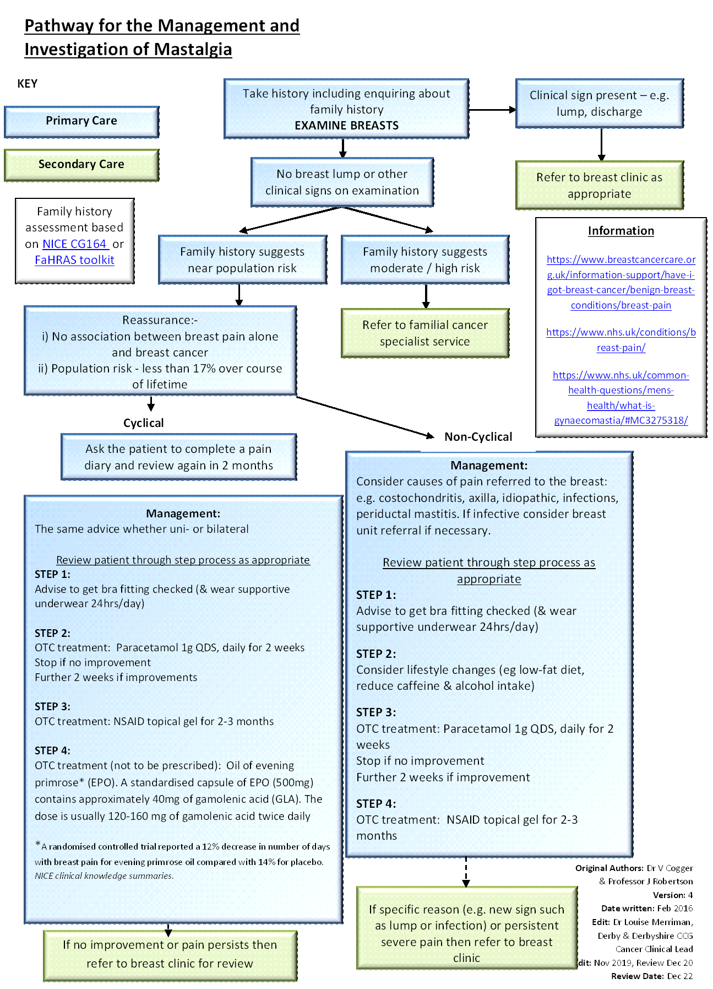

Appendix A

**Information**

<https://www.breastcancercare.org.uk/information-support/have-i-got-breast-cancer/benign-breast-conditions/breast-pain>

<https://www.nhs.uk/conditions/breast-pain/>

[[https://www.nhs.uk/common-health-questions/mens-health/what-is-gynaecomastia/#](https://www.nhs.uk/common-health-questions/mens-health/what-is-gynaecomastia/)MC3275318/](http://www.ncbi.nlm.nih.gov/pmc/articles/PMC3275318/)

**Information**

<https://www.breastcancercare.org.uk/information-support/have-i-got-breast-cancer/benign-breast-conditions/breast-pain>

<https://www.nhs.uk/conditions/breast-pain/>

[[https://www.nhs.uk/common-health-questions/mens-health/what-is-gynaecomastia/#](https://www.nhs.uk/common-health-questions/mens-health/what-is-gynaecomastia/)MC3275318/](http://www.ncbi.nlm.nih.gov/pmc/articles/PMC3275318/)

Family history assessment based on [NICE CG164](http://www.nice.org.uk/guidance/cg164) or [FaHRAS toolkit](http://www.fahras.co.uk/questionnaire/login.aspx)

Family history assessment based on [NICE CG164](http://www.nice.org.uk/guidance/cg164) or [FaHRAS toolkit](http://www.fahras.co.uk/questionnaire/login.aspx)