B.E.S.T Event
Wednesday 18th September 2019
12.45pm to 5.00pm
The Griffin Suite, Shaw Lane Sports Club, Barnsley, S70 6HZ

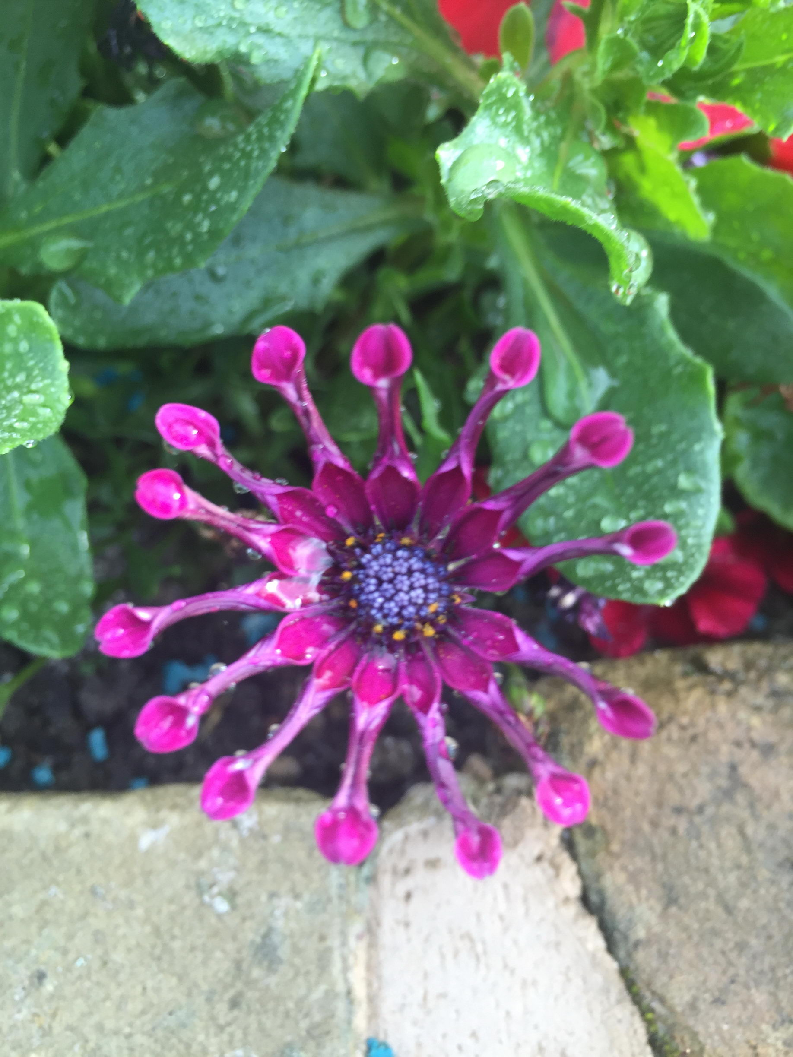

Gynaecology
Dr R Raychaudhuri, BHNFT
Contraception update
Dr B Wunna, Spectrum Community Health
Gram Negative Bacteraemia & IV Antibiotic Service
Dr J Rao, BHNFT

***Closing date for booking cover is Wednesday 4th September 2019***
If you have any queries please contact Michelle Thompson on 01226 433674 michelle.thompson26@nhs.net

GP B.E.S.T. Event & OOH/111 Booking Form

BEST EVENT

Wednesday 18th September 2019

12.45pm – 5.00pm

Shaw Lane Sport Club, Barnsley, S70 6HZ

Name of Practice:

Practice Address:

Contact Email Address:

Contact Telephone Number:

Contact Name:

Please reserve place(s) for the following staff (list name(s) & designation of staff attending): -
Name: | State if GP, Practice Nurse, etc
Please indicate if buffet is required:  * If yes, please advise of any special dietary requirements: |  | Yes
 |  | No
Please indicate if OOH / 111 cover is required for your practice:  OOH / 111 cover may not be required if not all GPs from your practice are attending the event. |  | Yes
 |  | No

Notice to practice managers; If GP’s from your practice are booked and do not attend or leave early you will be charged for the out of hours cover.

**Closing date for booking – 4th September 2019**
Thank you for taking time to complete the booking form. Please email michelle.thompson26@nhs.net

