|  |  |  |  |
| --- | --- | --- | --- |
|  | | **SOFT TISSUE SARCOMA**  ***Urgent Suspected Cancer (USC) referral***  ***Please refer via e-Referral Service*** | |
| **Please use separate children’s proforma for patients under 16.**  **Please note - suspected bone malignancy in patients 40 years and over should be referred via e-RS to the local orthopaedic urgent suspected cancer service (utilising bone malignancy in >40 years specific form), who can assess, investigate further and decide if the patient needs to be referred onto a local cancer service or specialist bone tumour unit**  **Please note: suspicious bone lesions in patients under 40 years with no history of previous malignancy should be referred directly to the Royal Orthopaedic Hospital (ROH) in Birmingham via e-RS RAS system.** | |

|  |  |  |  |
| --- | --- | --- | --- |
| **Patient details** | | | |
| **Patient Name** | ${firstname} ${surname} | | |
| **Address** | ${patientAddress}  ${postcode} | | |
| **DOB** | ${dob} | **NHS No.** | ${nhsNumber} |
| **Home Tel. No.** | ${home} | **Gender** | ${gender} |
| **Mobile Tel. No.** | ${mobile} | **Ethnicity** | ${ethnicity} |
| **Preferred Tel. No.** | ${preferredNumber} | **Email Address** | ${email} |
| **Main Spoken Language** | ${language} | **Interpreter needed?** | Yes  No |
| **Transport needed?** | ${transportNeeded} | **Patient agrees to telephone message being left?** | Yes  No |
| **Communication requirements** | Hard of hearing:  Visually impaired:  Learning/mental difficulties:  Dementia:  Has the patient capacity? Yes  No  Communication difficulties other: (please specify)  ${communicationDifficultiesOther} | | |
| **Safeguarding concerns?** | ${safeguardingConcerns} | | |
| **Date of Decision to Refer** | ${createdDate} | | |

|  |  |  |  |
| --- | --- | --- | --- |
| **Registered GP details** | | | |
| **Practice Name** | ${practiceName} | | |
| **Registered GP** | ${usualName} | **Usual GP / Referring GP** | ${referringClinical} |
| **Registered GP**  **Address** | ${practiceAddress} | | |
| **Tel No.** | ${main} | **Fax No.** | ${fax} |
| **Email** | ${gpEmail} | **Practice Code** | ${practiceCode} |

|  |  |
| --- | --- |
| **Patient engagement** | |
| **The patient has been informed that the reason for referral is to rule out or rule in Cancer.** |  |
| **Supporting information (USC leaflet) provided** |  |
| **The patient has been informed of the likely next pathway steps and the time in which they should be contacted?** |  |
| **Please confirm the patient has been informed they may need to attend Sheffield Teaching Hospitals to undergo further imaging investigations and possibly biopsy prior to out-patient appointment (mandatory prior to referral)** |  |
| **Does the patient want a relative present at the appointment** | Yes  No |
| **Patient or Carer Concerns/ Support Needs at the point of referral:** | |
| ${carerConcernsOrSupportNeeds} | |
| **Has the patient had ultrasound/X-ray/MR imaging prior to referral (mandatory prior to referral)?** | Yes  No |
| **Imaging will be reviewed in the sarcoma MDT and if we are satisfied the lesion shows no concerning features of malignancy, the patient may not need to attend an out-patient sarcoma clinic. You will receive a copy of the MDT outcome with advice about any further management that may be required.** | |

|  |  |
| --- | --- |
| **Referral criteria** | |
| **Ultrasound scan findings are suggestive of soft tissue sarcoma** |  |
| **Ultrasound findings are uncertain and clinical concern persists** |  |

|  |  |
| --- | --- |
| **Order urgent soft tissue ultrasound (within 2 weeks)** | |
| **Palpable lump with any of the following: (check if present)** |  |
| * **Size is greater than 5cm** |  |
| * **Adherent to deep fascia; fixed immobile** |  |
| * **Painful** |  |
| * **Increasing in size** |  |
| * **Recurrence after previous excision** |  |

|  |
| --- |
| **Location of suspected bone lesion (please mark location)** |

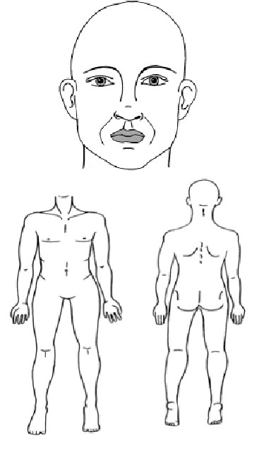

|  |
| --- |
| **Please add clinical details and examination findings**  **(this can be copied from your consultation note)** |
| ${symptomsAndExaminationFindings} |

|  |  |  |
| --- | --- | --- |
| **Anticoagulation status** | | |
| **Is the patient currently on any anticoagulants?** | Yes  No | ${anticoagulantsTextarea} |
| **Is the patient currently on any antiplatelet medications?** | Yes  No | ${antiplateletsTextarea} |

|  |  |
| --- | --- |
| **Relevant investigations** | |
| **All patients requiring a 'suspicious of cancer' referral must have a recent (< 3 months) U&E result to facilitate efficient pathway next steps.** | |
| **U&E** | ${renalFunctionG} |
| **FBC** | ${fbcG} |
| **LFTs** | ${lftG} |
| **Clotting** | ${clottingG} |
| **TFTs** | ${thyroidFunctionG} |
| **Ultrasound soft tissue** | ${ultrasoundSoftTissue} |
| **Other** | ${relevantInvestigations} |

|  |  |
| --- | --- |
| **Performance status - WHO classification** | |
| **0 - Able to carry out all normal activity without restriction** |  |
| **1 - Restricted in physically strenuous activity, but able to walk and do light work** |  |
| **2 - Able to walk and capable of all self-care, but unable to carry out any work. Up and about more than 50% of waking hours** |  |
| **3 - Capable of only limited self-care, confined to bed or chair more than 50% of waking hours** |  |
| **4 - Completely disabled. Cannot carry on any self-care. Totally confined to bed or chair** |  |

**Consultations**

${additionalClinicalInfo}

**Past Medical History**

${medicalHistory}

**Family history**

${relevantFamilyHistoryOfCancer}

**Current Medications**

${medication}

**Allergies**

${allergies}

|  |  |
| --- | --- |
| **To be completed by the Hospital Data Team** | |
| **Date of decision to refer** |  |
| **Date of appointment** |  |
| **Date of earliest offered appointment (if different to above)** |  |
| **Specify reason if not seen at earliest offered appointment** |  |
| **Periods of unavailability** |  |
| **Booking number (UBRN)** |  |
| **Final diagnosis: Malignant**  **Benign** | |

**Summary of the NICE 2015 Suspected Cancer Guidelines**

|  |  |
| --- | --- |
| **Soft Tissue Sarcoma** | |
| Consider an urgent direct access ultrasound scan | In adults with an unexplained lump that is increasing in size. |
| Consider cancer pathway referral | For adults if they have ultrasound scan findings that are suggestive of soft tissue sarcoma or if ultrasound findings are uncertain and clinical concern persists. |