B.E.S.T Event

Wednesday 16th November 2016
12.45pm to 5.00pm
Shaw Lane Sports Club, Shaw Lane, S70 6HZ
Ear, Nose and Throat

Management of ALL common ENT conditions!☺
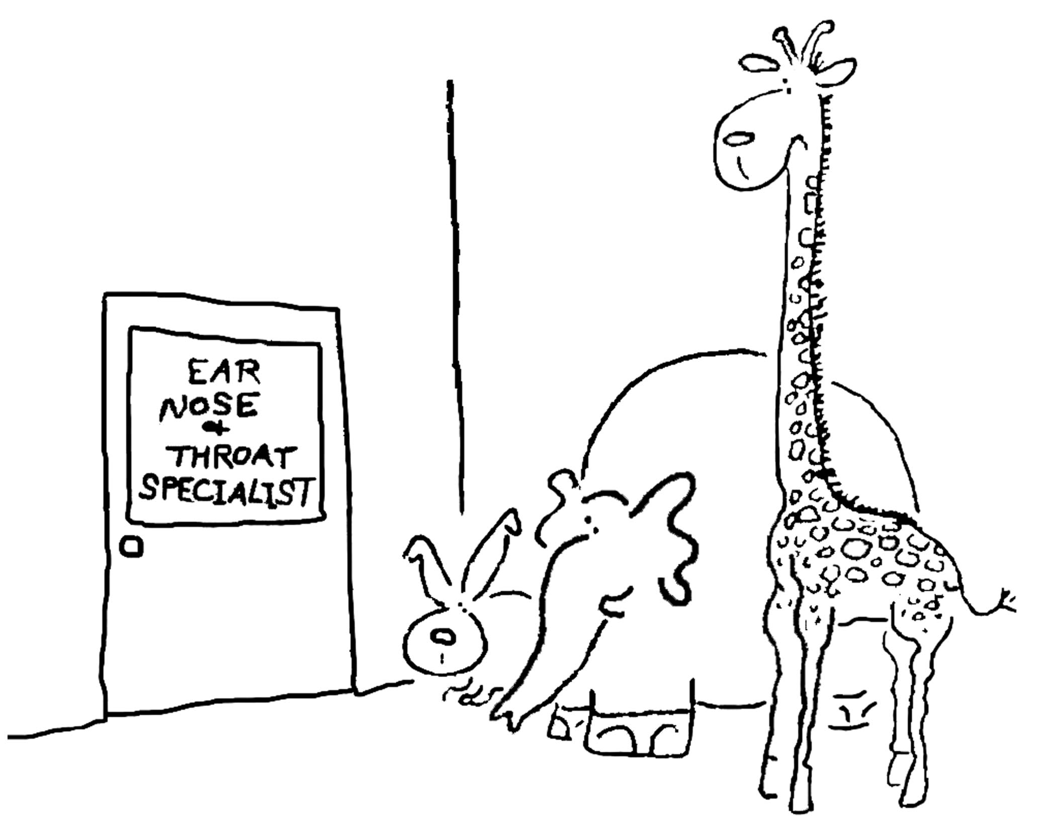
Mr Martin Wickham, Consultant ENT Surgeon
Mr Michael Nussbaumer, MD Consultant ENT Surgeon
Mr Austin Smith, Consultant Maxillofacial and Head and Neck Oncology Surgeon
Mr Siddiqui, Consultant ENT Surgeon
ENT SHO’s & Registrars
ENT / Audiology Specialist Nurses and Practitioner
Speech and Language Therapists
**Closing date for booking 2nd November 2016 **
If you have any queries please contact michelle.thompson26@nhs.net
GP B.E.S.T. Event & Care UK/111 Booking Form
Ear, Nose and Throat

BEST EVENT

Wednesday 16th November 2016

12.45pm – 5.00pm

Shaw Lane Rugby Club, Shaw Lane, Barnsley

Name of Practice:

Practice Address:

Contact Email Address:

Contact Telephone Number:

Contact Name:

Please reserve place(s) for the following staff (list name(s) & designation of staff attending): -

Name: | State if GP, Practice Nurse, etc
Please indicate if buffet is required:  * If yes, please advise of any special dietary requirements: |  | Yes
 |  | No
Please indicate if Care UK / 111 cover is required for your practice:  Care UK / 111 cover may not be required if not all GPs from your practice are attending the event. |  | Yes
 |  | No

Notice to practice managers; if GP’s from your practice are booked and do not attend or
leave early you will be charged for the out of hours cover.

**Closing date for booking – 2nd November 2016**

Thank you for taking time to complete the booking form.

Please email michelle.thompson26@nhs.net or

