B.E.S.T Event
Thursday 6th April 2017
12.45pm to 5.00pm
Shaw Lane Sports Club, Shaw Lane, S70 6HZ
Gastrointestinal Update
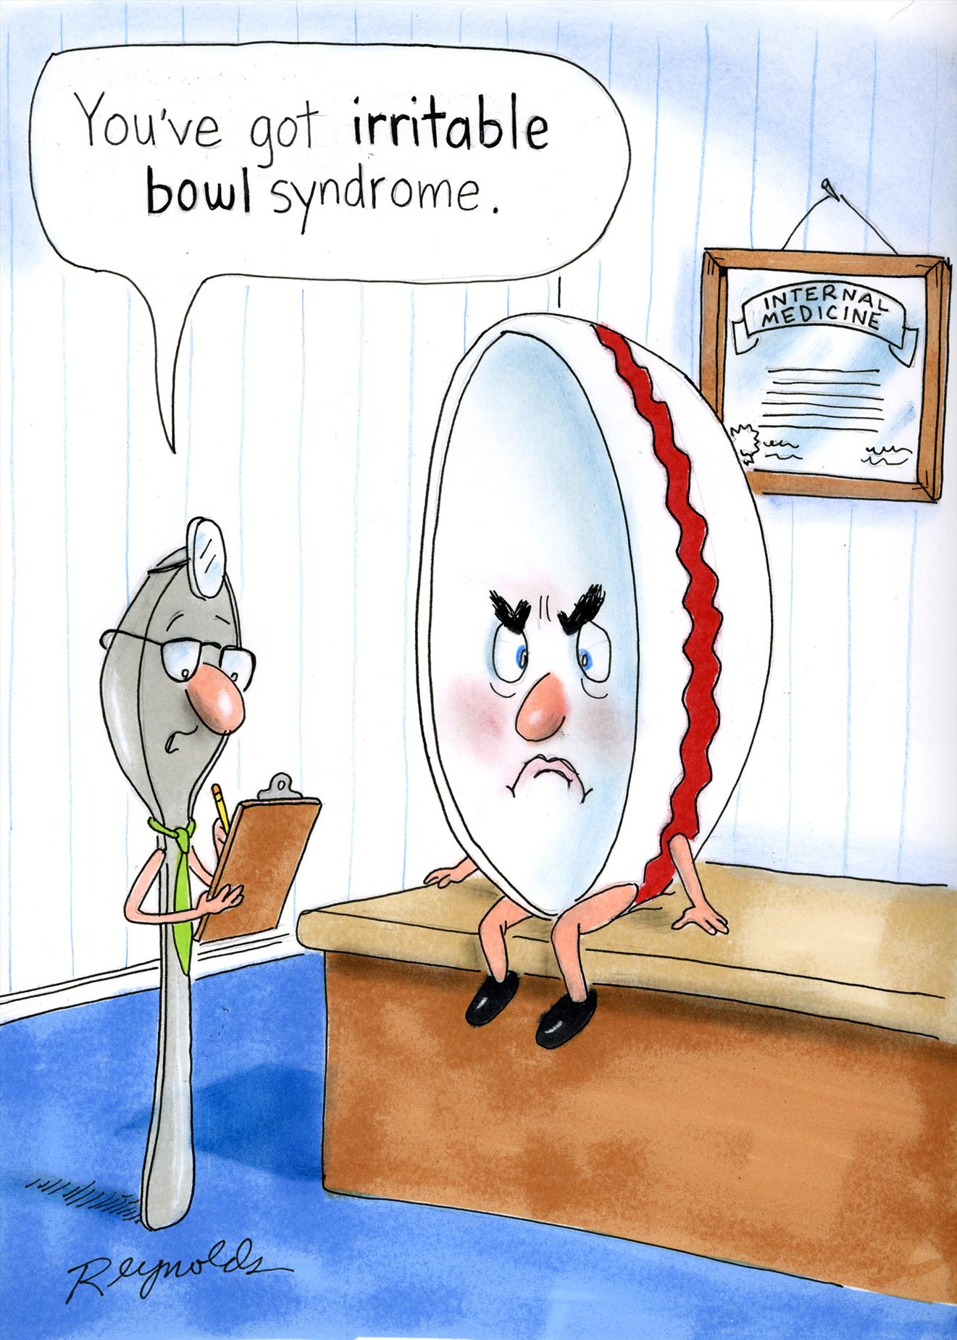
Dyspepsia
Irritable Bowel Syndrome
Constipation
Lower GI Colonoscopy

Dr Bullas, Dr Kapur, Dr Atkinson, Dr Said
Consultant Gastroenterologists from Barnsley Hospital

Moinka Bettney Gastroenterology Dietician
St Georges Hospital, London

***Closing date for booking is 23rd March 2017***

If you have any queries please contact Michelle Thompson on
01226 433674 michelle.thompson26@nhs.net
GP B.E.S.T. Event & Care UK/111 Booking Form

Gastrointestinal Update

BEST EVENT

Thursday 6th April 2017

12.45pm – 5.00pm

Shaw Lane Rugby Club, Shaw Lane, Barnsley

Name of Practice:

Practice Address:

Contact Email Address:

Contact Telephone Number:

Contact Name:

Please reserve place(s) for the following staff (list name(s) & designation of staff attending): -

Name: | State if GP, Practice Nurse, etc
Please indicate if buffet is required:  * If yes, please advise of any special dietary requirements: |  | Yes
 |  | No
Please indicate if Care UK / 111 cover is required for your practice:  Care UK / 111 cover may not be required if not all GPs from your practice are attending the event. |  | Yes
 |  | No

Notice to practice managers; if GP’s from your practice are booked and do not attend or
leave early you will be charged for the out of hours cover.
**Closing date for booking – 23rd March 2017**
Thank you for taking time to complete the booking form.
Please email michelle.thompson26@nhs.net

