B.E.S.T Event
Wednesday 15th June 2016
12.45pm to 5.00pm
Shaw Lane Rugby Club – Griffin Suite, S70 6HZ
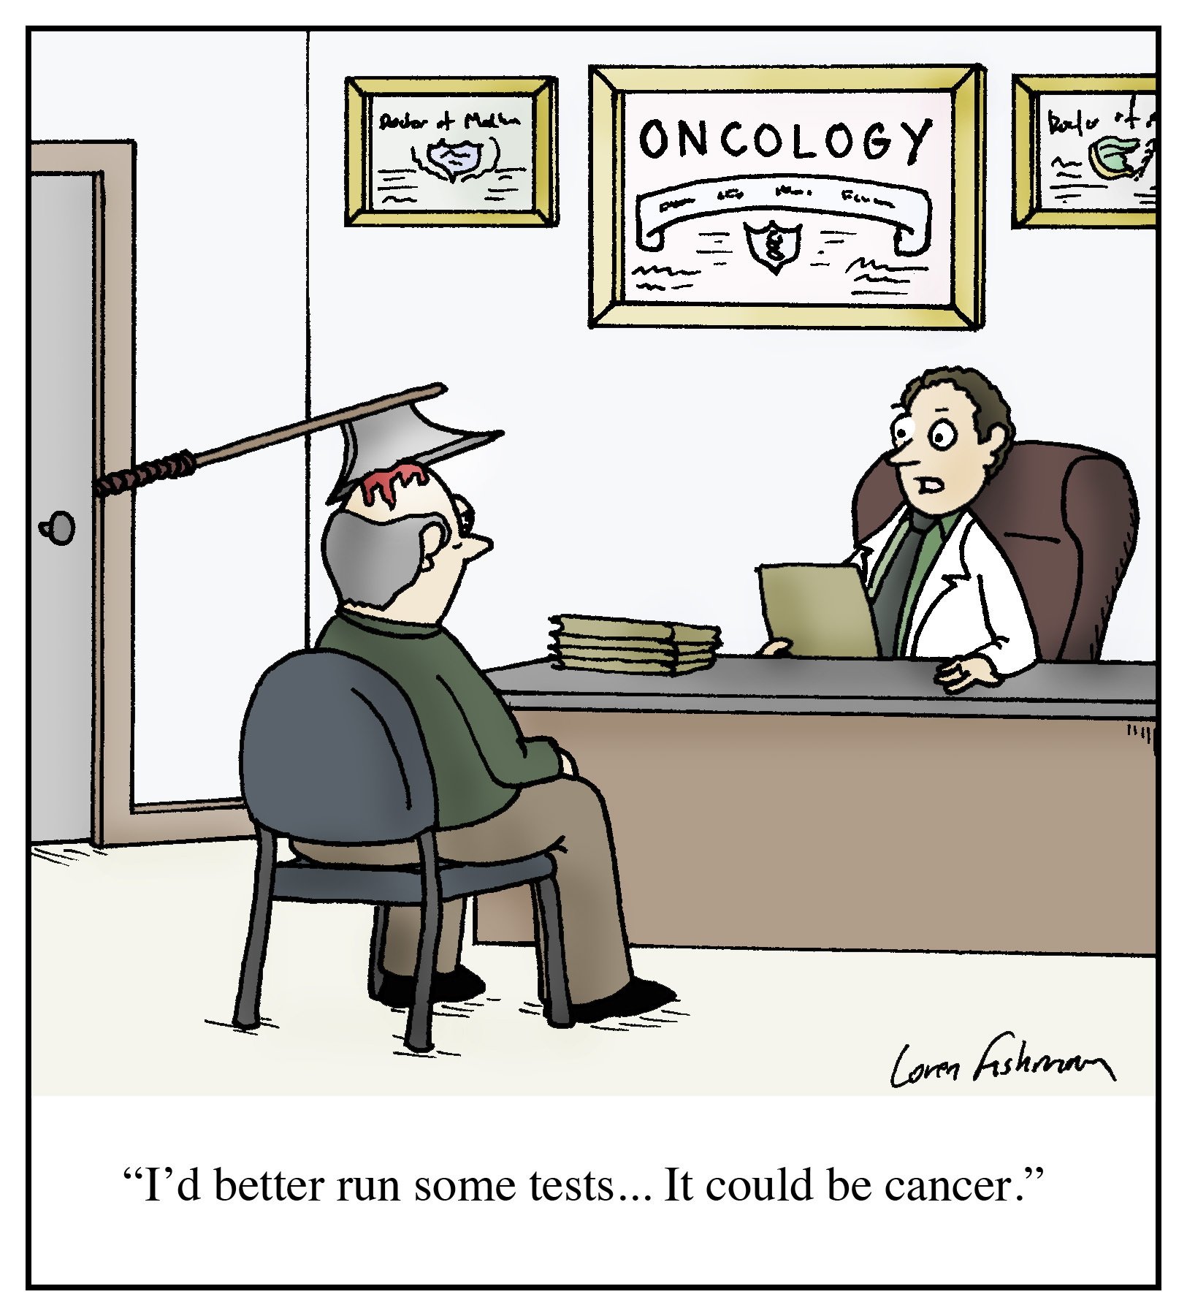
- Cancer 2 week wait
- NICE Guidelines
- BHNFT Specialist referral forms
- Cancer UK research

** Closing date or bookings is 1st June 2016 **
If you have any queries please contact Michelle Thompson on 01226 433674 michelle.thompson26@nhs.net
GP B.E.S.T. Event & Care UK/111 Booking Form
Cancer 2 week wait, NICE guidelines,
BHNFT specialist referral forms, Cancer UK research

BEST EVENT

Wednesday 15th June 2016

12.45pm – 5.00pm

Shaw Lane Rugby Club, Shaw Lane, Barnsley

Name of Practice:

Practice Address:

Contact Email Address:

Contact Telephone Number:

Contact Name:

Please reserve place(s) for the following staff (list name(s) & designation of staff attending): -

Name: | State if GP, Practice Nurse, etc
Please indicate if buffet is required:  * If yes, please advise of any special dietary requirements: |  | Yes
 |  | No
Please indicate if Care UK / 111 cover is required for your practice:  Care UK / 111 cover may not be required if not all GPs from your practice are attending the event. |  | Yes
 |  | No

Notice to practice managers; if GP’s from your practice are booked and do not attend or
leave early you will be charged for the out of hours cover.

**Closing date for booking – Wednesday 1st June 2016**

Thank you for taking time to complete the booking form.

Please email Samantha.sinclair5@nhs.net or
send to Hillder House, 49-51 Gawber Road, Barnsley, S75 2PY

