OMMT Tier 2, at Barnsley Town Hall.
9am-4.30pm (including lunch and break times)
Address/access
Barnsley Town Hall
Usually in room 11 (second floor) – reception can confirm on day
Use side entrance at Lancaster Gate. Reception can direct people.
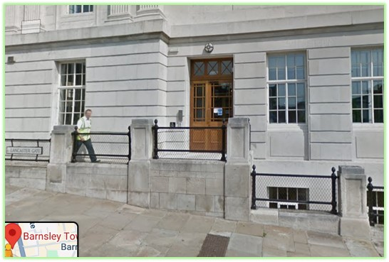
Facilities
Café downstairs in town hall. Other options (Greggs etc) within walking distance.
Encourage bringing packed lunch and flasks to reduce queues/delays at breaks.
Kitchen available to make own drinks at break times.
Toilets on same floor as training room.
Accessible toilet available.
Stairs or lift to training room.

Parking and further accessibility info:
https://www.accessable.co.uk/barnsley-metropolitan-borough-council/access-guides/barnsley-town-hall#b24862f2-0aa6-4c62-9ca5-adfdbc4b92b3

