

Patient zone

**Complex Wound Care** *for the ANTT Practice Framework see:* www.**antt**.org

**using Surgical-ANTT** (Improvise the work surface* for the Community / Home Care setting)

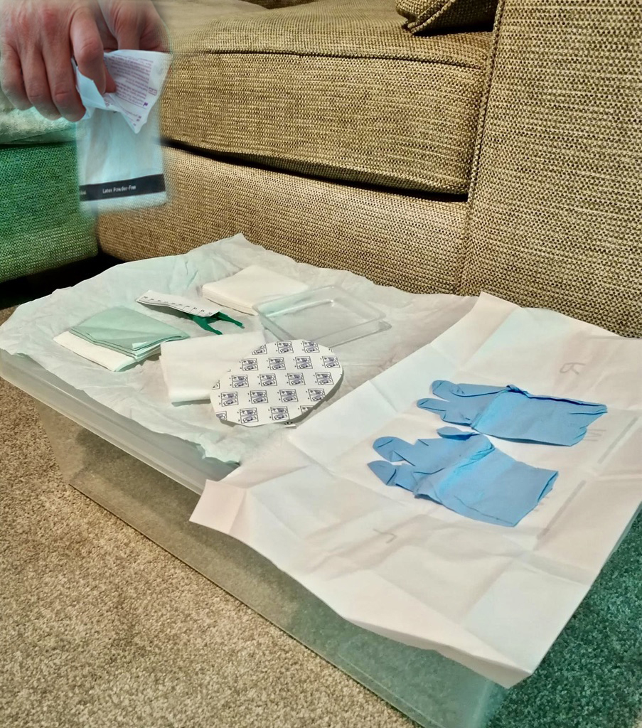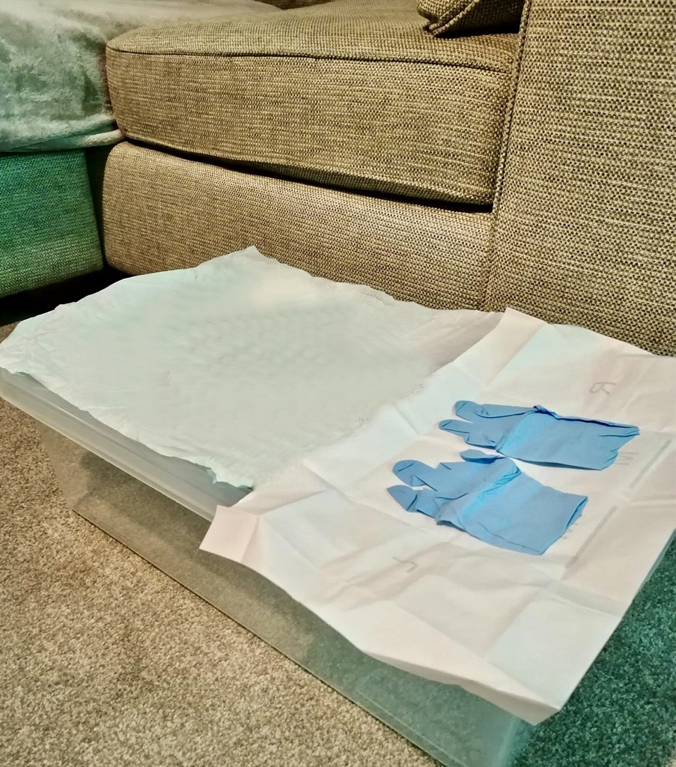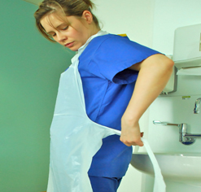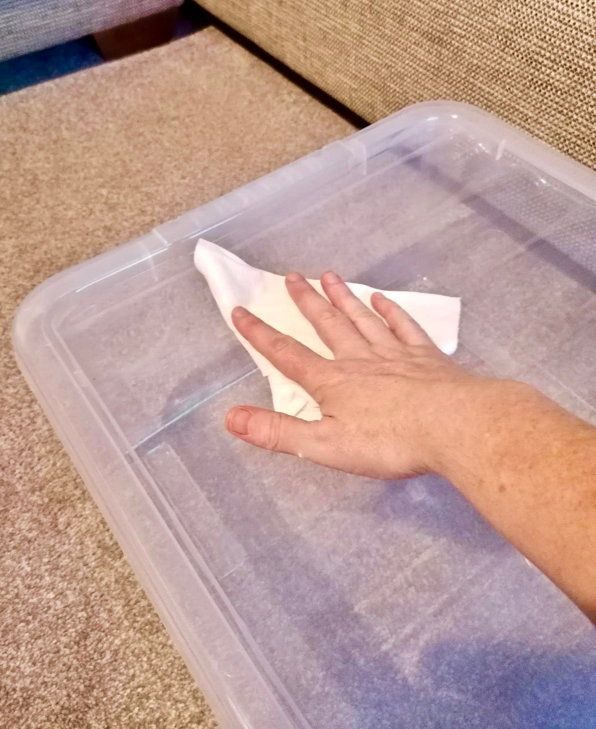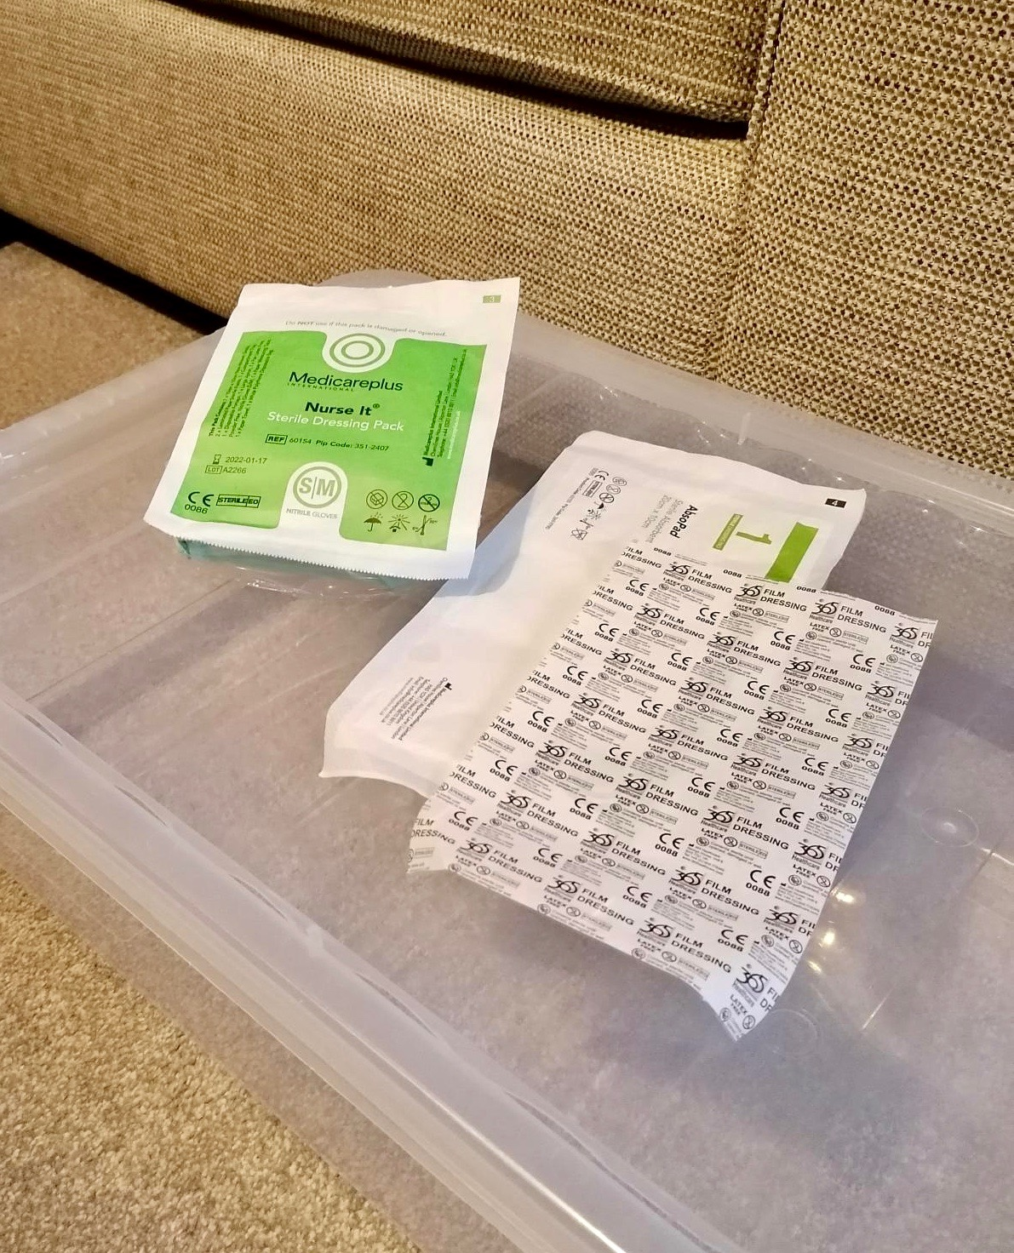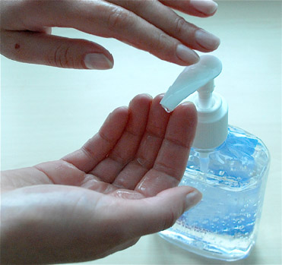

**5**

**3**

**6**

**2**

Preparation zone

**1**

**4**



**Open Wound Pack** creating a **Critical Aseptic Field**

**Apply Disposable Apron** & disinfect hands with alcohol rub or soap and water

**Disinfect Surface\***

according to local policy creating a **General Aseptic Field**

**Disinfect Hands**

with alcohol hand rub

or soap & water

**Prepare Equipment**

protecting **Key-Parts** using non-touch technique (NTT)

**Gather Wound Pack**

& equipment & place around the prepared working surface

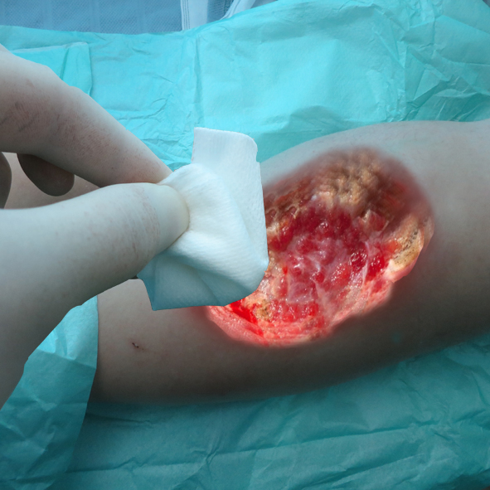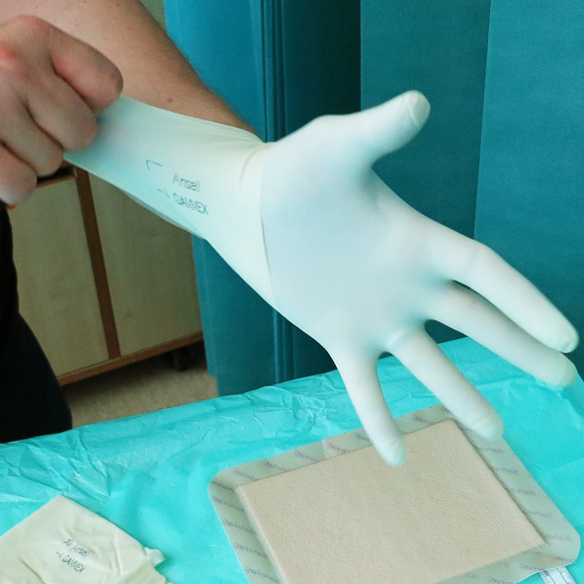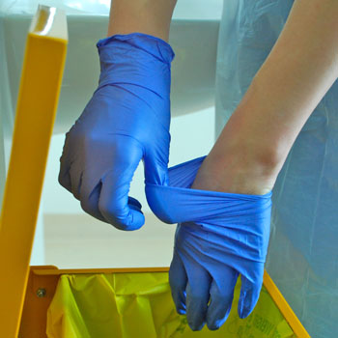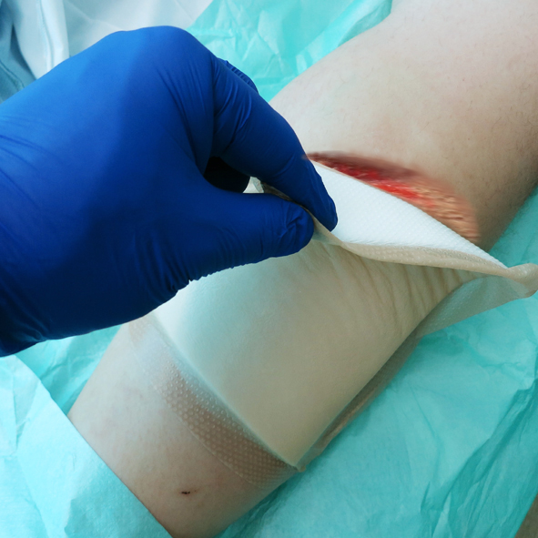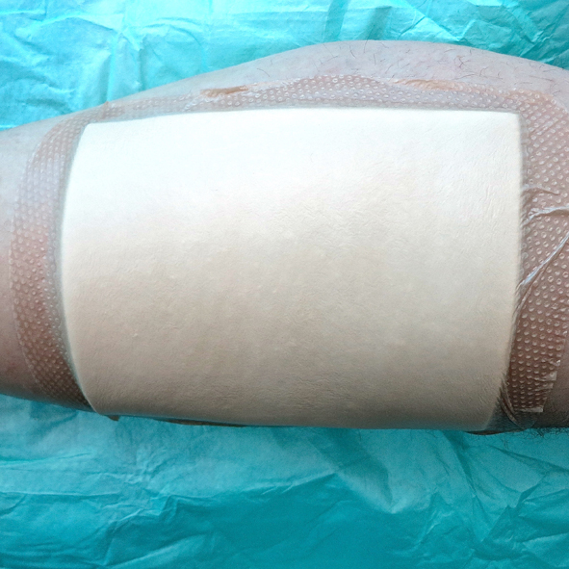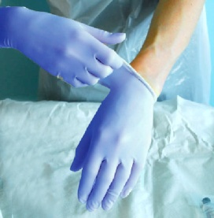

**13**

**9**

**11**

**10**

**7**

**8**

**12**

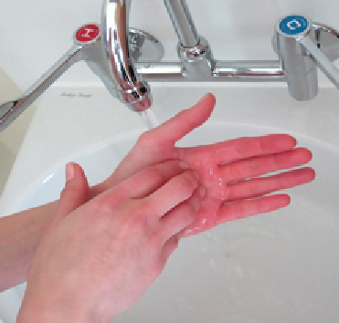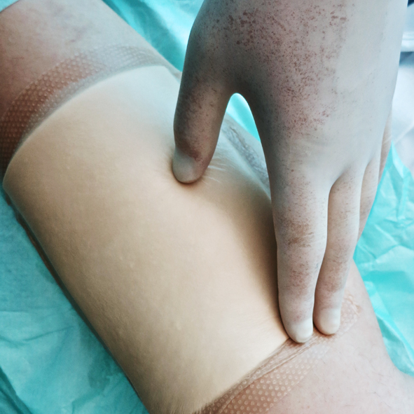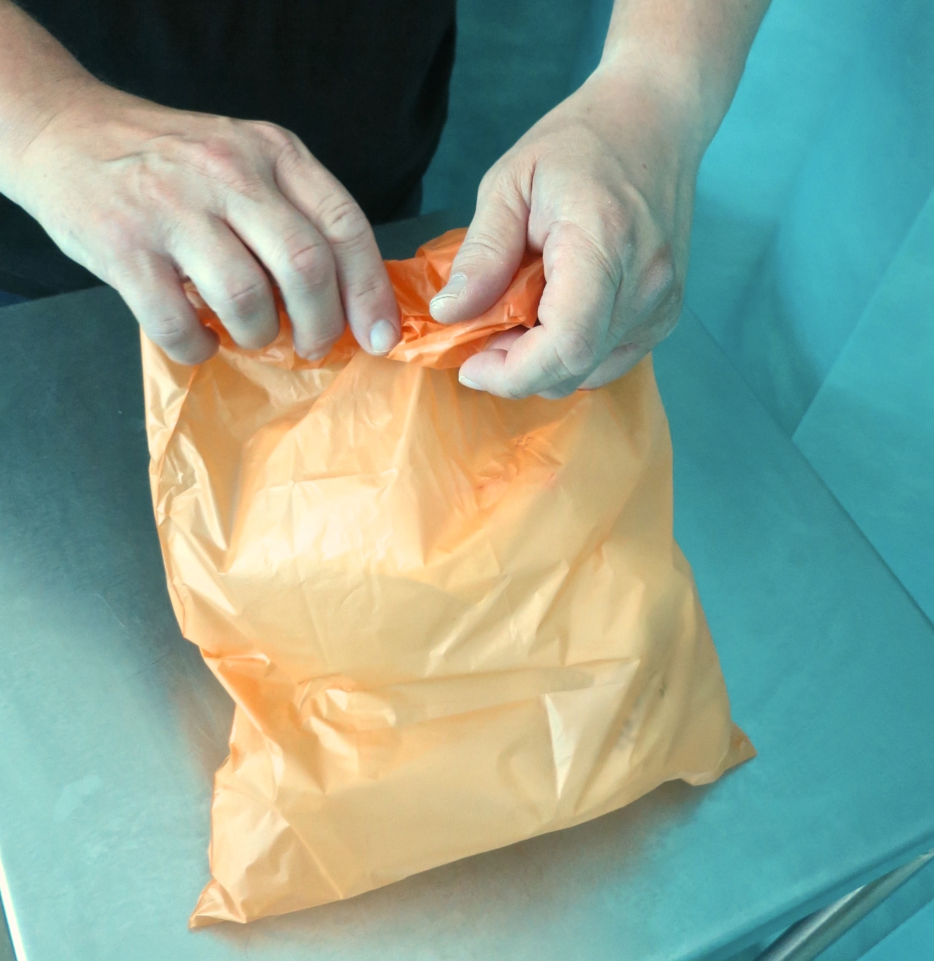

**Disinfect Surface** according to local policy

**17**

**Place Drape**

under the wound

**Remove Dressing**

protecting **Key-Site**

using NTT & dispose

of dressing in waste bag

**Apply Sterile Gloves**

**Apply Gloves**

as per local policy

**Dispose of Gloves**

**Disinfect Hands**

with alcohol hand rub

or soap & water

**Clean Wound**

protecting **Key-Site** using NTT

**15**

**16**

**Disinfect Hands**

with alcohol hand rub

or soap & water

**14**

**18**

**Dispose of Waste**

& equipment remove

gloves & apron & immediately….

**Dress Wound**

using NTT

**Disinfect Hands**

with alcohol hand rub

or soap & water

Decontamination zone

**Your Organisation Logo Here**

ANTT® © v4.0 Please note that local policy or equipment changes may be applied. For advice, please see enquiries@antt.org