Dear [name of patient]

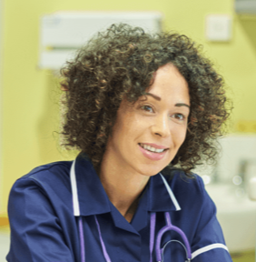  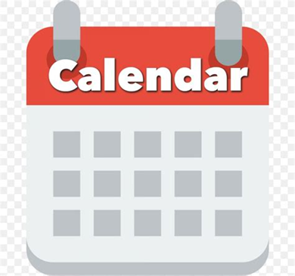 | My name is Sarah, I am a Nurse at Woodhouse Health Centre.  Please come and see me for your yearly health check on Thursday 24th February at 10:10 am
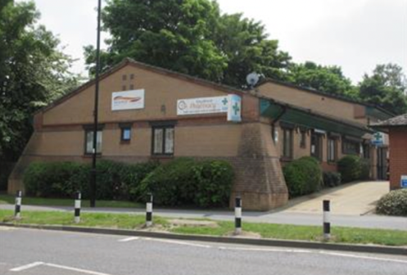 | We are here:  Woodhouse Health Centre  5-7 Skelton Lane  Woodhouse  Sheffield S13 7LY
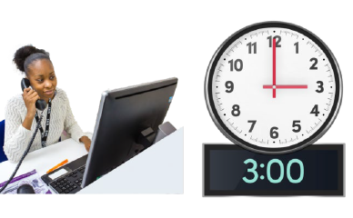 | You can call us and change the day or time.  Our phone number is 0114 229 3090  Please call us after 3:00 in the afternoon.

Why are health checks important?

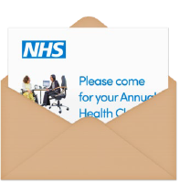 | People with learning disabilities can have more health problems than other people.  Having a yearly health check will help you to stay fit and well.

What will happen?

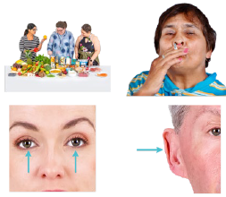 | You will be asked some questions about your health like:  - What food do you eat  - Do you smoke  - Do you have problems with your eyes or ears
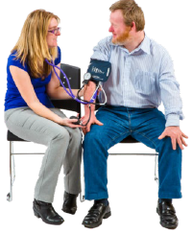 | We can check your blood pressure, to see if it is high or low.  If your blood pressure is too high or too low it might cause health problems, so it is good to check.  Most people have normal blood pressure, so there is no need to worry.
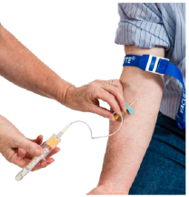 | We can take a blood test.  This is where a needle takes a small amount of your blood.  We can check for any problems or diseases.Most people have no problem with their blood, so there is no need to worry.
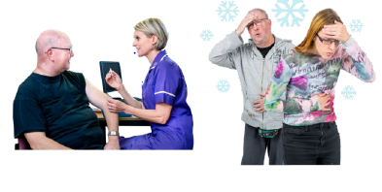 | You may be given a flu vaccination.  This is a needle that makes sure you will not get flu and feel unwell this Winter.

Do you have any questions?

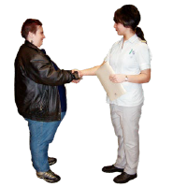 | If you have any worries you can speak to the Health Care Assistant.
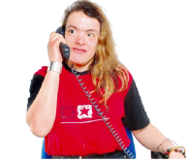 | You can phone us on 0114 229 3090

I am looking forward to seeing you soon

Nurse Sarah Street-Rose


