
Adding Hospital Prescribed Drugs to EMIS WEB

All medicines prescribed and routinely dispensed by the hospital should be entered on to the patient’s clinical record. This ensures that a full and up to date list of a patients current medication is provided when referrals and choose and book appointments are made. It also ensures that any drug interactions with hospital only drugs are highlighted to the prescriber when new drugs are added in primary care.

Select the patient and in their medication screen:
- Click ‘Add Drug’
- Select correct drug, form and strength from picking list either by double clicking it or highlighting correct drug and pressing enter. (NOTE- for methotrexate a dosing box will appear with pre-set doses and quantities. For hospital issued methotrexate only press cancel and follow procedure below).
- In the directions box type e.g. ‘DISPENSED BY THE HOSPITAL ONLY. See latest *******clinic letter for current dose’.
- In the quantity box type ‘0’ (zero). If prompted to add number of ‘authorised issues’ enter 0 (zero).
- Select ‘Repeat medication’ in drop down list

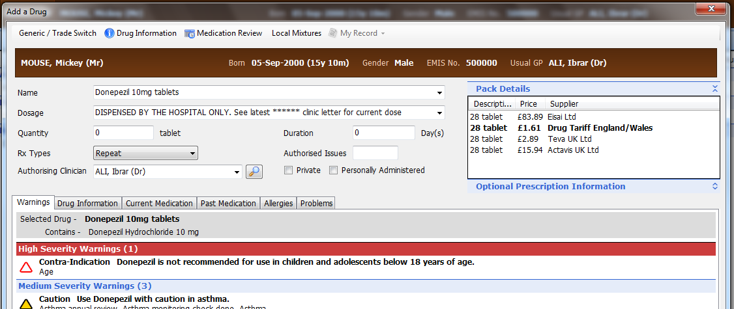

- Click ‘Issue’ button
- Select ‘Record Hospital (no print)’ by clicking on ‘Change all’ drop down list

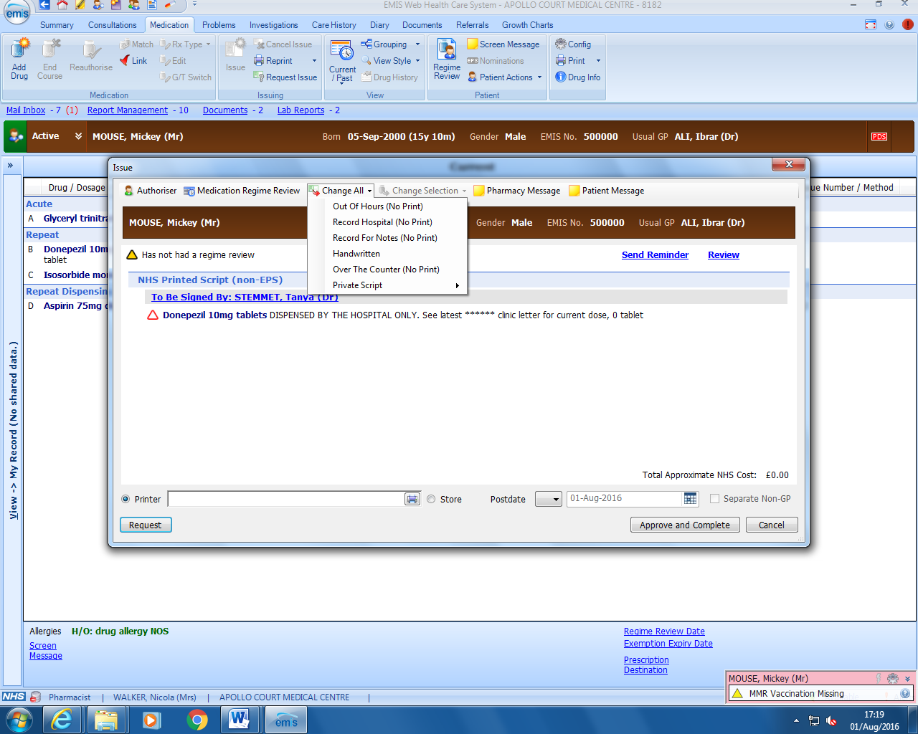

- Click ‘Approve and complete’
- This medication will state ‘Record Hospital’ in the ‘last issue number/method’ column and will be listed in a ‘Hospital’ section on the medication screen

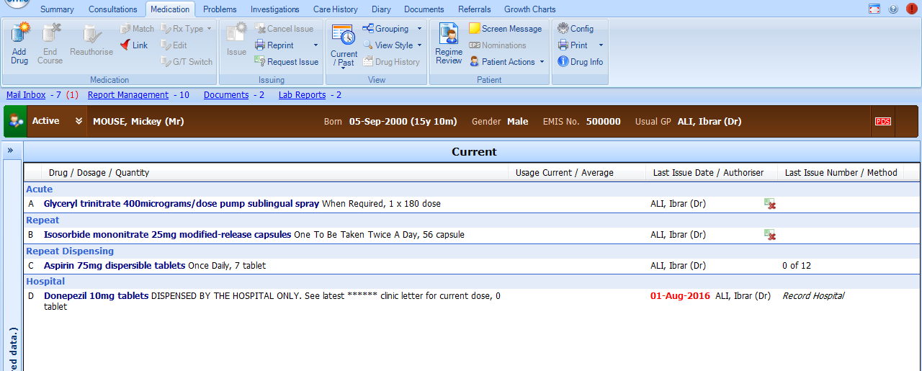

- If the medication is ‘issued’ in error, EMIS Web will show a pop up screen message to notify you that the medication is a hospital issue and will ask for the issuer for an over-ride reason before the prescription can be printed.

