B.E.S.T Event
Wednesday 15th February 2017
12.45pm to 5.00pm
Shaw Lane Sports Club, Shaw Lane, S70 6HZ
Clinical Thresholds for Referrals
BEST Website Developments

Cataract surgery Hernias Benign skin lesions
Ganglion cysts  Trigger finger
Dupuytren's Varicose Veins Grommets
Carpal tunnel syndrome
Hip replacement Knee replacement
Cholecystectomy Tonsillectomy Hysterectomy
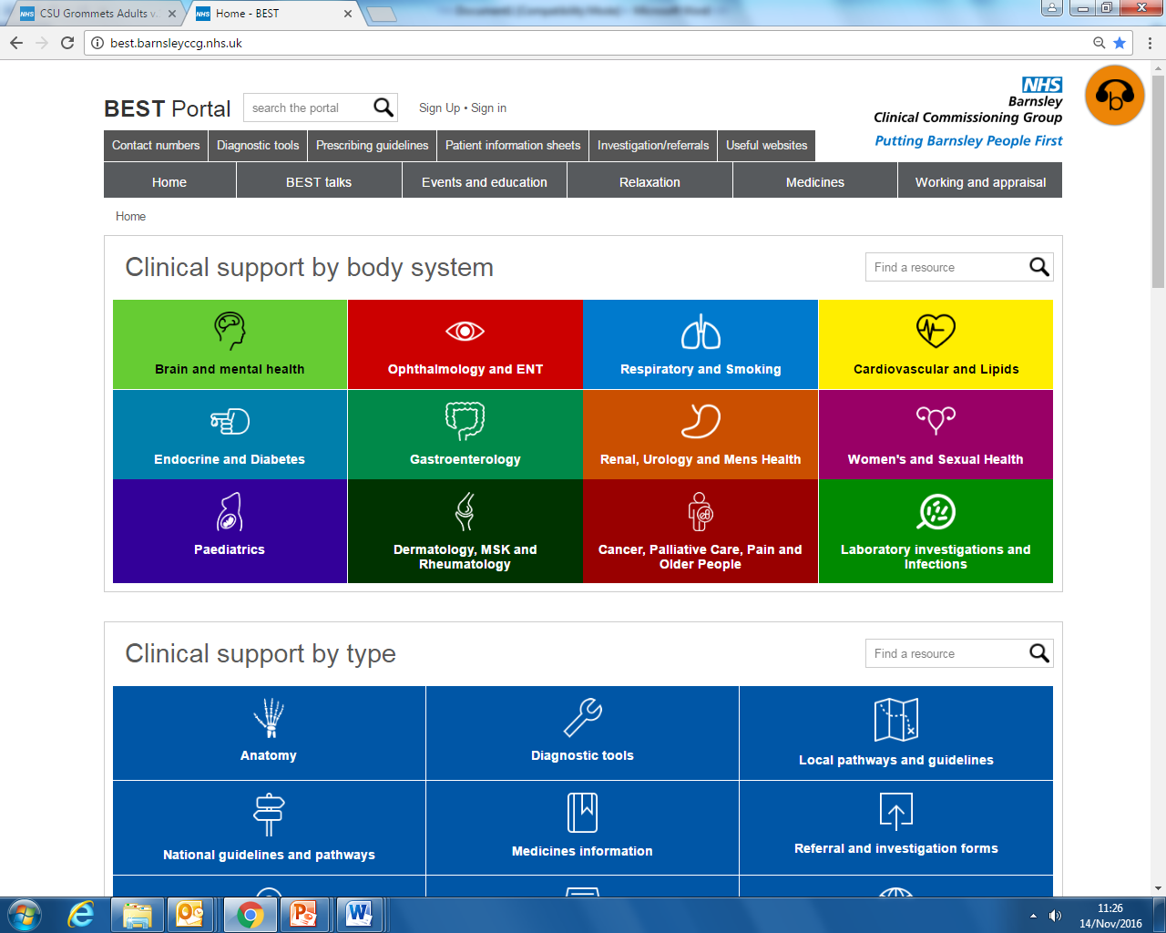

***Closing date for booking is 1st February 2017***
If you have any queries please contact Michelle Thompson on
01226 433674 michelle.thompson26@nhs.net
GP B.E.S.T. Event & Care UK/111 Booking Form
Clinical Thresholds for Referrals

BEST Website Developments

BEST EVENT

Wednesday 15th February 2017

12.45pm – 5.00pm

Shaw Lane Rugby Club, Shaw Lane, Barnsley

Name of Practice:

Practice Address:

Contact Email Address:

Contact Telephone Number:

Contact Name:

Please reserve place(s) for the following staff (list name(s) & designation of staff attending): -

Name: | State if GP, Practice Nurse, etc
Please indicate if buffet is required:  * If yes, please advise of any special dietary requirements: |  | Yes
 |  | No
Please indicate if Care UK / 111 cover is required for your practice:  Care UK / 111 cover may not be required if not all GPs from your practice are attending the event. |  | Yes
 |  | No

Notice to practice managers; if GP’s from your practice are booked and do not attend or
leave early you will be charged for the out of hours cover.
**Closing date for booking – 1st February 2017**
Thank you for taking time to complete the booking form.
Please email michelle.thompson26@nhs.net

