`

**Healthy Child Program-Barnsley**

Clinical Referral Pathways

**Contents**

**1.** **Hearing screening**

**2.** **Vision screening**

**3.** **Heart Murmurs**

**4.** **Congenital hip dysplasia**

**6.** **Screening for undescended testes**

**6.** **Failure to thrive**

**7.** **Obesity**

**8.** **Developmental screening**

**9.** **Referral form**

**Colour Code Key :**

** Hospital**

**Indicates need to refer**

** GP**

** Health visitor**

MH.Tumi- Consultant Paediatrician July, 2016

# HEARING SCREENING

**At Birth:**

All babies are offered acoustic emission test at the time of discharge or at 4weeks corrected age. This is part of a national screening programme pilot and was adopted in BHNFT from January 2002.

Results of the hearing test must be documented in the hospital notes and GP notified. ABR (auditory brain response) if results of OAE (otoacoustic emission) abnormal.

**At 6-8 Weeks:**

Check child has been screened and results entered in records. Verify history again

**At 7-12 months:**

*•“Can your baby hear you?”* questionnaire from Parent Held Record.

•Any child with developmental delay or visual impairment should be referred to the audiology clinic at New-street clinic.

**At all subsequent screening:**

Refer if language and/or general developmental delay, **parental concerns**, recurrent ear infections leading to secretary otitis media and behavioural difficulties.

**Indication for referral to Audiology**

* Direct evidence of hearing loss e.g. parental concern.
* Indirect evidence of hearing loss: speech delay, behavioural problems, learning difficulties.
* High risk babies e.g. prematurity, low birth weight, auto toxic medication, family history of hearing loss
* Other problems such as: recurrent ear infections, meningitis and syndromes with related hearing loss. Failure of the hearing screening programme including the neonatal and sweep programme.

**Hearing Screening Pathway**

Birth

6-8 weeks

7-9 months

At all subsequent screening opportunities

Acoustic emission (OAE) Test undertaken

Ensure OAE results recorded in notes

* Can your baby hear your (PCHR)
* Check for developmental delay/visual impairment

Observe for:

* Language delay
* General developmental delay
* Recurrent ear infection
* PARENTAL CONCERNS

**Concern Identified**

**Indication for referral to Audiology:**

* Direct evidence of hearing loss e.g.: Parental concern
* High risk babies; prematurity, low birth weight, auto toxic medication, family history
* Other problems e.g. recurrent ear infections, meningitis, syndromes with related hearing loss
* Failure of the Hearing screening programme including the neonatal and sweep programme (school entry)

**Refer to audiology**

# VISION SCREENING

**At all Ages:**

1. Ask about **family history** of ocular problems (e.g., congenital defect, squint, refractive error). Children at risk of a genetically determined disabling eye disorder should be examined with extra care, preferably by an ophthalmologist.
2. Children with **dysmorphic syndromes or neuron-developmental problems** should undergo a specialist eye examination as some of them may have serious visual defects.
3. Be sensitive to **parental concerns.** Always ask parents if they think:

* Their child’s eyes are normal
* Their child can see well (use *“Can your baby see well?”* questionnaire)
* A squint has ever been noticed

**General Observations:**

* + Note any abnormal features of eyes or eyelids
  + Permanent squint beyond 6 weeks of age is abnormal (refer to paediatrics)

ₒ Do not assume that a child who has been seen in the Hospital Outpatient Department has normal vision, do check again.

**Observations and tests for pre-school children:**

|  |  |  |
| --- | --- | --- |
| **Age** | **Clinical assessment and Screening tests** | **Responsibility** |
| **All babies** | Health visitor to draw parent’s attention to *“Can your baby see?”* questionnaire in the parent-held record. | Health visitor |
| **6-8 weeks** | **Red reflex**  To be carried out by the doctor or appropriately trained professional  To check for congenital cataract, retinoblastoma. The pupil is observed through an Ophthalmoscope sat at 3+ from a distance of about 30 cms.  Opacities show clearly through the red reflex of the retina  Observed  **Squint:**  Ask parents if they have observed a squint. Look for clinically obvious squint. | **GP** |
| **6-8 weeks** | **Visual behaviour**  Ask mother if baby can look at and follow her face.  Note general visual interest in near surroundings.  Get baby to fixate on your face/torch light at 1m and follow it through at least 30 degrees either side of midline (no auditory clues should be given).  Roving eye movements and nystagmus are abnormal. |  |
| **7-12 months** | **Squint**  Ask parents if Ask parents if they have seen a squint and look for clinically obvious squint.  **Ocular movements**  Using attractive stimulus (e.g., attractive toy), observe fixating and following in both horizontal and vertical planes, conjugate movement of the eyes and test for convergence.  **Visual behaviour**  Infant should show interest in ‘Smartie’ or small pellet placed on table and reach out for it. | **Health Visitor** |
| **2 years** | **Squint**  Ask parents if they have seen a squint. Look for clinically obvious squint.  **Visual behaviour**  Ask parent if child can recognise familiar objects at a distance (e.g., dog, cat, and airplane).  Test for hand-eye co-ordination and pincer grip using hundreds and thousands with both eyes open. | **Health Visitor visitor** |
| **31/2year r** | **Squint**  Ask parents if they have seen a squint and look for clinically obvious squint.  **Visual behaviour**  Ask if parents have concerns about vision |  |

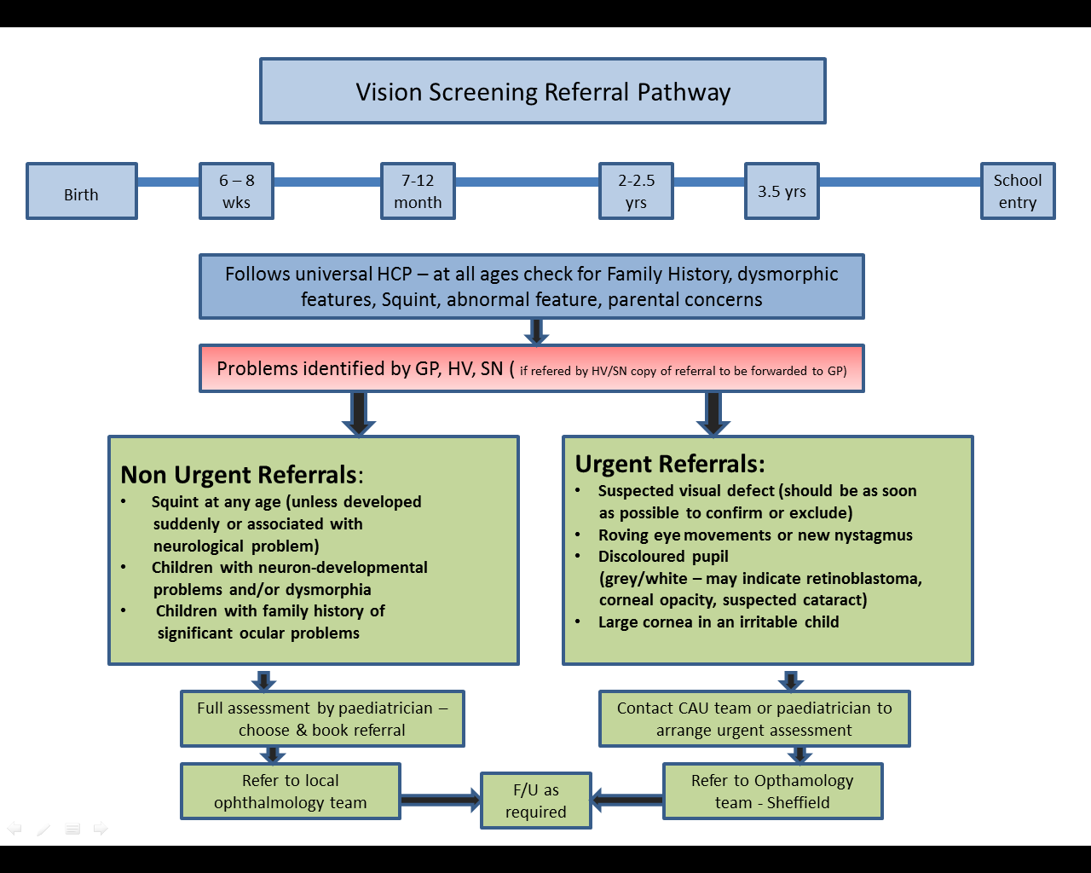

# Congenital Heart Disease

Although congenital heart disease is a relatively common defect (6:1000 births), the average GP will only see one such case every 5 years. Whereas most severe cases present at or soon after birth, a few initially asymptomatic but potentially serious cases (including ASD and pulmonary stenosis) may escape detection until later childhood. A few milder cases of congenital heart disease (including small VSDs, small ASDs or mild PS) remain asymptomatic but should if possible be picked up because bacterial endocarditis prophylaxis may be required and long term follow is needed

**SCREENING FOR CONGENITAL HEART DISEASE**

|  |  |  |
| --- | --- | --- |
| **Age** | **Clinical signs and screening for heart murmur** | **Responsibility** |
| **6-8 Weeks** | * Remember that signs of congenital heart disease in the young   infant include cyanosis, tachypnoea, slow feeding, failure to thrive and repeated chest infections.   * Examine the cardiovascular system including: * Listen for cardiac murmurs * Palpitation of femoral pulses | **by GP or**  **skilled**  **other** |
| **8months-4½ years** | * GP’s should be prepared to respond to parents requests to find suitable opportunities to listen for cardiac murmurs in children between 8 months and 4.5yrs. This can be done when children present to clinic or surgery either for routine immunisation (e.g: MMR at 13 months, pre school booster) or with respiratory tract infection, pyrexial illness etc. The majority of children will present to Primary Health Care Services in one of these ways between 1-4yrs | **GP** |

**Innocent Murmurs**

Innocent murmurs in childhood are common. They may be heard in children of all ages, most commonly those under 12 years and in those who are febrile

**Differential Diagnosis of Innocent and Pathological Murmurs**

Paediatric cardiologists and paediatricians can readily distinguish pathological murmurs from innocent ones on clinical examination and history alone. However, the role of the primary health care doctor is not to make a final diagnosis, but to be able to differentiate, on hearing a murmur, the children who are at high risk of having heart disease from those who are low risk.

The following guidelines may assist in this process.

**Characteristics of Murmur**

Murmurs are graded in intensity from 1 to 6.

Murmurs of grade 4 and upwards are accompanied by a palpable thrill.

|  |  |
| --- | --- |
| **INNOCENT** | **PATHOLOGICAL** |
| 1. Soft, always less than 3/6, often musical. 2. Well localised, usually to left sternal edge, occasionally to pulmonary area or carotid arteries. 3. Always systolic (usually short early or mild systolic). 4. Heart sounds normal. 5. Never associated with symptoms and signs of heart disease. | 1. Often louder than 3/6 but may be soft. 2. May radiate (same intensity at different sides. 3. May be diastolic/pansystolic/ late systolic /continuous. 4. Heart sounds may be abnormal. 5. May be associated with symptoms and signs of heart disease.   E.g. Abnormal BP.  Abnormal peripheral pulses.  Thrill. Cyanosis.  Congestive heart failure. |

Referral Pathway for Heart Murmur

HOSPITAL

IN PRIMARY CARE

Heart murmur (including intermittent murmur) detected at Primary Care

Symptomatic

Asymptomatic

Unwell with feeding problems and/or respiratory problem, intermittent cyanosis and poor weight gain

**Urgent referral to CAU/Paediatrician**

Choose & Book referral to paediatrician

Full assessment by paediatrician

Heart murmur detected during baby check at the hospital- Follow hospital Guidelines. See appendix 1

If discharged and still have a heart murmur or heart problems. Send a copy of discharge letter to HV

HV to monitor weight monthly and observe for signs of heart failure (feeding and breathing problems)

If poor weight gain or baby unwell and/or symptomatic- refer to paediatrician/CAU

# DEVELOPMENTAL DYSPLASIA OF THE HIP – DDH

DDH includes a spectrum of conditions where the head of the femur may be partly or completely displaced from the acetabulum.

Thus, DDH may include:

* True dislocation present from birth – CDH
* Varying degrees of instability which can evolve over time and may or may not result in dislocation

**High Risk Babies**

* Breech Presentation – extended breech in particular
* Oligohydramnios (too little amniotic fluid)
* Babies with congenital postural deformities of lower limbs, feet and other joints e.g. talipes, straight knees, torticollis + plagiocephaly, etc.
* Positive family history.
* First degree relative. More distant relative if definite history of dislocation with definitive treatment or hip replacement due to osteoarthritis at a young age.

## Family History of ‘clicky’ hips without any clinical intervention is to be disregarded

**DDH – Summary of Screening Programme**

|  |  |  |
| --- | --- | --- |
| **Age** | **Screening tests** | **Responsibility** |
| **Within 24-48 hours of birth** | Modified Ortolarni-Barlow manoeuvre:  identifies a dislocated or dislocatable hip with a **CLUNK** not CLICK. | **Hospital doctor in most cases but occasionally GP – refer to Hip Guideline on Appendix 2** |
| **6-8 weeks assessment:** | Ortolarni-Barlow manoeuvre as above.  **HV/GP Classic Signs:**   * Leg posture * Above knee limb shortening * Asymmetry of thighs – high ileo groin crease * Limitation of abduction * Buttock flattening | **GP responsibility at 6 to 8 week examination** |
| **6-13months** | **Classic Signs:**   * Leg Posture * Above knee limb shortening * Asymmetry of thighs-high ileo groin creases * Limitation of abduction * Buttock flattening | **HV/GP** |
| **14-24 months** | **Assessment of Gait:**   * Failure to walk by 18 months * Limp on affected side * Waddling gait + lumbar lordosis in bilateral dislocation * Plus previous signs as at 6-13 months.  Signs of bilateral dislocation: Wide perineum (in babies)   * Waddling gait as above * Limited abduction * Positive Ortolani-Barlow } 12 to 14 weeks only | **HV/GP** |

Developmental **Dysplasia** of the Hip Referral Pathway

**\*Mr N Nicolao’s Secretary Tel: 01226 432569**

**Fax No: 01226 432774**

Newborn baby check at hospital

SHO/Registrar

See Hospital guidelines

Appendix 2

< 3 months (6-8wks)

Normal Hips

GP assessment at 6-8 weeks

Positive Ortolani Barlow test

Urgent referral to paediatrics *orthopaedic secretary- by FA**X for * USS**

NB- Ensure high risk children with no abnormalities are being dealt with by Hospital

> 6 months

?Hip problems identified by GP/HV

- High asymmetry proximal creases (gluteal or groin)

-Limitation of abduction

-Unequal leg length

Refer to Dr Moussa Hip Clinic at BHNFT

Abnormal Gait

?Hip problems identified by GP/HV

-Waddling gait

-Limp or hip pain

-Delayed walking

Referral to Paediatrics consultant either by Choose & book or direct referral depending upon severity

**NB: If direct referral from HV/SN please send copy of referral to GP**

Definition of High Risk Babies

* Breech Presentation- extended breech in particular
* Oligohydramnios (too little amniotic fluid)
* Babies with congenital postural deformities of lower limbs, feet and other joints e.g. talipes, straight knees, torticollis +plagiocephaly etc.
* Positive family history
* First degree relative
* More distant relative if definite history of dislocation with definitive treatment or hip replacement due to osteoarthritis at a young age

> 3 months

?Hip problems identified by GP/HV

High asymmetry ilea-groin creases with limitation of abduction and above knee unequal length

Urgent referral

Directly to

Dr Mousse

Other problems e.g. Clicky Hip refer to Dr Moussa Hip Clinic at BHNFT



-Clicky Hip

-Asymmetrical groin or gluteal creases

Refer to Dr Moussa Hip Clinic at BHNFT

**Dr Moussa-Associated specialist at BHNFT**

Currently *USS done a Sheffield

# SCREENING FOR UNDESCENDED TESTES

**Summary of Screening Programme**

|  |  |
| --- | --- |
| **Neonatal** | **Hospital paediatrician/GP/MW (if trained)** |
| **6-8 weeks** | **GP** |

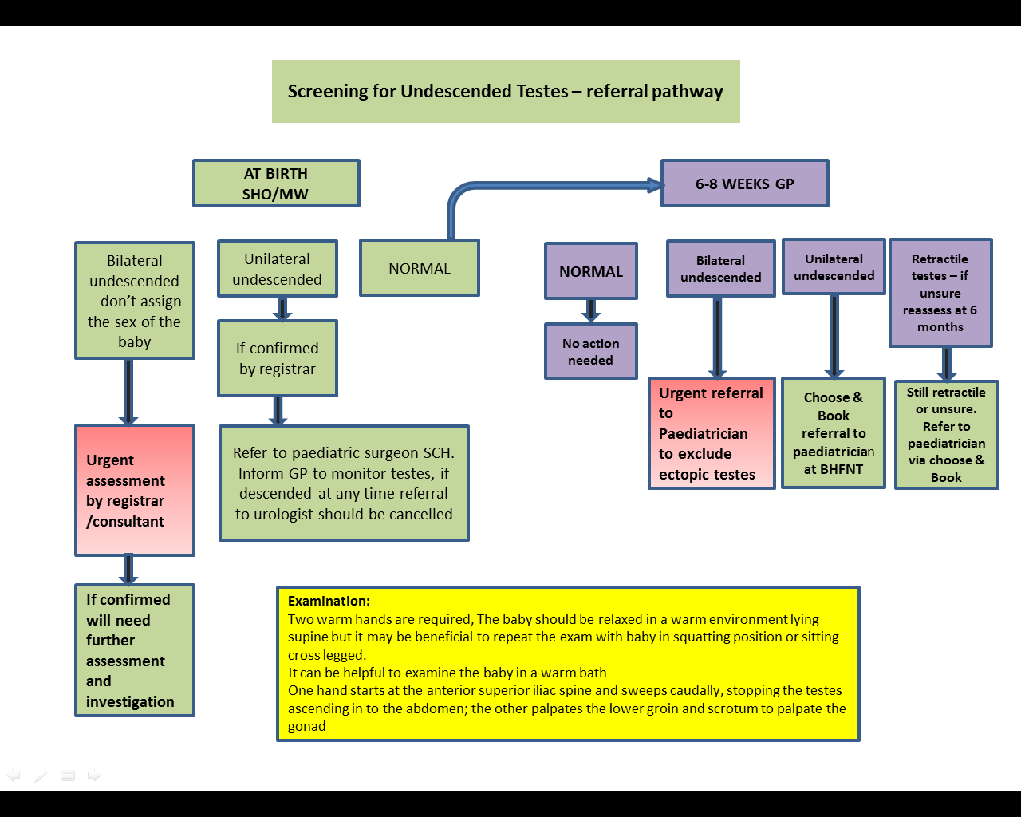

**Examination:**

Two warm hands are required. The baby should be relaxed in a warm environment lying supine but it may be beneficial to repeat the examination in squatting or sitting cross legged. It can be helpful to examine the baby in a warm bath. One hand starts at the anterior superior iliac spine and sweeps caudally, stopping the testes ascending in to the abdomen; the other palpates the lower groin and scrotum to palpate the gonad.

**References:**

1. Healthy Child Programme (2009) –pregnancy and the 1st 5 years DOH [www.dh.gov.uk/publication](http://www.dh.gov.uk/publication)

2. Health for all Children (4th edition).David Hall and David Elliman.2003

3. Community Paediatrics (3rd edition)-Leon Plonay.2002

4. Westacott D,Cooke S. Developmental Dysplasia of the Hip.Arch dis child.2012 Nove; 85(11):42-44

# REFERRAL PATHWAY AND MANAGEMENT OF WEIGHT FALTERING (FAILURE TO THRIVE)

**NB: All monitoring of children should be undertaken in accordance with Barnsley’s Growth Monitoring Guidelines (SWYFT/BHNFT 2014)**

**AIM**

To ensure that the family of every young child wise weight is faltering (previously known failure to thrive), receive an appropriate assessment and where necessary a timely package of care

To provide a universal integrated approach to the professionals managing children with faltering growth.

**DEFINITION**

Faltering growth (FTT) is a descriptive term and refers to less than expected growth over time during the first 3 years of life when tracked on appropriate growth charts for children of the same age and sex.

**TRIGGERS FOR CONCERN/PRIMARY CARE ASSESSMENT**

1. A sustained fall through 2 centile spaces (over period of 6 weeks) should always trigger an assessment

2. A weight or height below the 0.4th centile, noted for the first time, should always trigger an assessment.

3. Evaluation should be considered if weight or height is below the 2nd percentile

4. Weight gain less than expected. No weight gain for 2 months for children below 6 months and no weight gain in3 months for children >6 months .

5. Weight repeatedly fluctuating up and down

6. Have weight-for-length <80% of ideal weight*

*Ideal weight: Plot ideal weight for height. This is the same centile, e.g. height 25th centile - ideal weight 25th centile

**NORMAL WEIGHT GAIN**

|  |  |  |  |  |  |  |
| --- | --- | --- | --- | --- | --- | --- |
| Age(months) | **0-3** | **3-6** | **6-9** | **9-12** | **12-18** | **18-24** |
| Weight Gain (gram/day) | **20-30** | **15-20** | **10-15** | **6-11** | **5-8** | **3-7** |

**GROWTH CHARTS**

Use UK-WHO Charts 2009 (0-4 years)

Features include:

* Adult height predictor
* Body mass index convector
* Guidance on gestational age correction

UK-WHO thrive lines 5% 2009 layover acetates can help to interpret the acceptability of series of plotted weight (available from www.healthforall children.co.uk

**Growth chart for preterm**

Any baby born before 32 weeks should have a pre term growth chart (UK-WHO birth weight growth chart 2009), which will be administered by the neonatal unit. This should continue for the first 2 years of age. Babies born at 32-36 weeks should be plotted on the preterm section until 42 weeks gestational age and then transferred to the main charts. Correction should continue until 1 year using the drawn back method to indicate that professional is correcting for prematurity

Preterm babies32weeks or less: at the age of 2years use chronological age

Above 32 weeks use chronological at 1 year

**Catch down growth**

Children under 2 years may show catch down growth to their genetic centile making interpretation of growth charts more difficult. Birth weight is mainly determined by how well nourished they have been in utero. After 6 months of age genetic factors become more important and the rate of growth may slow until the baby/child reaches the centile where are the genetic contribution is more important (usually achieved by 2 years).

Typically in catch down both weight and height will fall through centiles at the same rate or, if the weight centile is more than height centile the weight centile alone may fall to match the height.

Catch down growth is unlikely to be the cause for fall through the centile:

* If this occurs rapidly
* Fall in height centile is preceded by a significant fall in weight centile
* There is a fall outside the target centile based on parental height
* History suggested an underlying cause

**Catch–up growth**

This is a rapid growth occurs in IUGR and after illness

**SUPPORTING INFORMATION**

Infants commonly show some weight faltering in the first two years, but it may affect older children. As a guide, population studies showed that 1 in 20 children under 2 years of age shows a sustained fall through two centile spaces for weight.

1 in 100 under 2 years of age shows a sustained fall through 3 centile spaces.

Only 5% of young children whose weight/growth falters will have an organic root to the problem. It is estimated that a further 5% will need the support of child protection agencies.

**Rationale;**

Faltering growth occurs in 5 % of children. It occurs in families from all socio-economic groups and culture children with disability are also affected.

In the past, response to young children’s faltering growth has not been well managed, with patchy provision of services and an uncoordinated approach. This has led to some children’s faltering weight and/growth being unrecognized (Bachelor & Ker lake 1990) while others have received damaging, inappropriate ineffectual responses (Raynor 2002:Undergrowth 2000)

Summary of evidence suggest that weight faltering in infancy does have an effect on long term growth and may have a small effect on cognition (BMJ 2012). Other potentially serious consequences for both the child and the family if the issues of weight and/growth faltering are not addressed these include delayed development, increase in family stress and dysfunctional eating behaviour on the part of the child

Services need to be child centred and to treat families with respect and dignity and to recognize the stress for all members of the family, including the child.

**Factors associated with Faltering Growth**

The early years are time of nutritional vulnerability due to young children’s rapid growth and high-energy requirement. Faltering growth generally has an inadequate intake of calories as basic problem. A number of factors may be associated with this including:

|  |  |  |
| --- | --- | --- |
| **Parent** | **Child** | **Medical Factors** |
| **Interactional difficulties between parents or carers and children** | **Inadequacy of the content or frequency of meals** | **Illness-although it’s rare for serious organic disease to present as growth faltering alone** |
| **Domestic violence** | **Poor inherent feeding drive** |  |
| **Abuse /or neglect** | **Oral motor dysfunction** |  |
| **Mental illness, Drug abuse** | **Developmental difficulties** |  |

**Age related risk factors:**

Weight faltering is closely related to feeding problems, but different mechanism seems to be involved at different age of onset. Slow weight gain within the 1st few weeks in first week of life strongly associated with LBW and gestational age, single parenthood and smoking during pregnancy. Onset between 2 weeks and 4 months was associated with congenital disorder and serious somatic illness, and with deviant mother-child relationship; where onset between 4 and 8 months seemed to present a group of children with feeding problems arising de novo in otherwise healthy child (8)

**PRIMARY CARE ASSESSMENT AND MANAGEMENT**

In those children where weight gain is a concern the family’s health visitor should negotiate a home visits (preferably at meal/feed times to allow observation). A range of data should be collected including feeding history; relevant medical or domestic details, mealtime routines, food diary etc.

Having identified areas where there is potential for change the health visitor should provide advice and on-going support. In fact, at the end of feeding assessment, the health visitor will be able to summaries her findings and make decision about further immediate action (she can discuss his/her finding with the associate specialist/GP or a member of the multidisciplinary feeding team, if needed).

The further management will be according to the flow chart. As a result of this discussion there are three possible alternative courses of action:

1. No cause for concern - normal surveillance

2. Advice offered

3. Referral to member of multi-disciplinary team

The health visitor should discuss the findings and plan of management with the family’s GP**.**

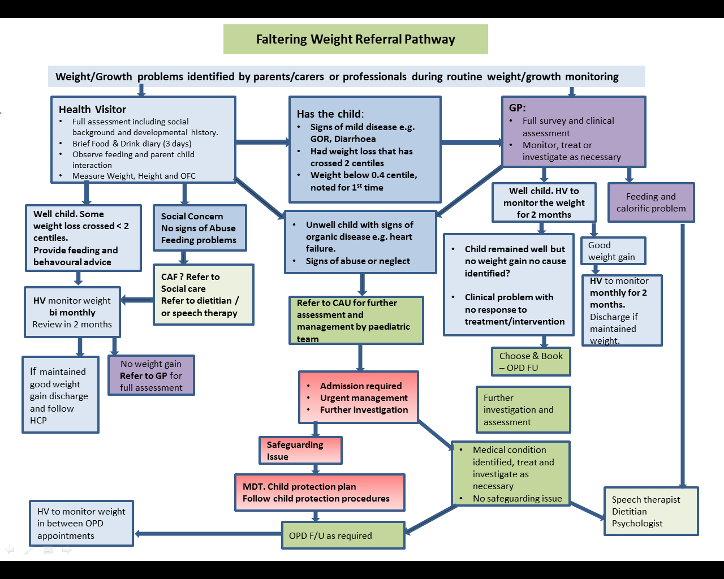

**PREVENTION OF WEIGHT FALTERING (FAILURE TO THRIVE - FTT)**

Prevention is possible by early identification during Health visitor screening

Enlisting dietitians or visiting nurses to provide psychosocial and educational support for families of children at increased risk of FTT may also reduce the likelihood that the child will develop FTT

**METHOD**

1. **Record birth weight**
2. **Weight at 5 days**
3. **10-14 day weight**
4. **Weight at 6 to 8 week check**
5. **Weight at 8-12 months check**
6. **Each time note head circumference& length**
7. **Plot on growth chart**

**To plot base line weight, add birth weight and weight at 8 weeks and divide by 2. Plot it by a red dot depicting average centile week 4 . If weighed at 6 weeks, the average centile will be plotted at 3 weeks age.**

**Monitor (if problem identified)**

**Infants below 6 months - Weigh every 2 weeks to 4 weeks for a period of 3 to 6 months.**

**Young babies ( >6 months of age) weigh every 4 weeks.**

**FEEDING ASSESSMENT AND SUMMARY –**

**MEDICAL ASSESMENT**

**1.** History - Full history including feeding and social history

**2.** Developmental assessment

**3.** Consider looking at behaviour of the child and interaction carer and child

**4.** Examination

1. Weight, length, head circumference
2. Physical examination
3. Look for dysmorphism
4. Interpret growth pattern

|  |
| --- |
| **Red Flag signs and symptoms suggesting medical causes of Faltering growth**   * **Cardiac findings suggesting congenital heart disease or heart failure (e.g., murmur, oedema, jugular venous distension)** |
| * **Developmental delay** |
| * **Dysmorphic features** |
| * **Failure to gain weight despite adequate caloric intake** |
| * **Organomegaly or lymphadenopathy** |
| * **Recurrent or severe respiratory, mucocutaneous, or urinary infection** * **Recurrent vomiting, diarrhoea, or dehydration** |
|  |

**5. Investigation that can be undertaken in Primary Care**

Indication includes persistent faltering growth, symptoms and signs of organic disease and failure of feeding and behavioural advice

|  |  |
| --- | --- |
| Test | Comments |
| **FBC, Ferritin** | **Anaemia, Iron store** |
| **MSU** | **Proteinuria, SG,C/S** |
| **Urea and electrolytes** | **Renal function** |
| **Bone profile + Consider Vit D level** | **Vit D, if signs or risk factors for rickets identified** |
| **TFT** | **For hypo- hyperthyroidism** |
| **LFT** | **Chronic infection** |
| **Coeliac screen**  **IgA immunoglobin** | **If the child had been on solid food for at least 3 months**  **Further investigation to be decided directed by the clinical signs** |

**Required action**

Significant abnormal examination &/or result of base line investigation refer to CONSULTANT

No abnormality→ Discuss with HV and refer back for monitoring. Have regular liaison with HV

Weight/growth recovery would usually be defined as catching up to within 2 centile spaces or their expected centile.

**INDICATIONS FOR ADMISSION TO HOSPITAL**

**1. To monitor weight gain with known caloric intake**

**2. Severe FTT especially in young infant**

**3. To observe the child’s behaviour and mother/child interaction**

**4. To plan for further investigation + arrange for MDT assessment**

**5. To gather evidence for child protection procedure**

**6. Weight below birth weight by 6 weeks**

WHO guideline for energy and protein intake for optimal catch-up growth

|  |  |  |  |
| --- | --- | --- | --- |
| **Rate of gain(g/kg/day)** | **Protein (g/kg/day)** | **Energy(g/kg/day)** | **Protein energy ratio P/E %** |
| **10** | **2.82** | **126** | **8.9** |
| **20** | **4.82** | **167** | **11.5** |

**PREVENTION**

Ensuring that pregnant women and young mothers of young children have access to good food.

1. Anticipatory guidance can be given to parents on changing nutritional needs and feeding patterns of the child. These include:

* Exclusive breastfeeding (or formula) for first 6 months
* When infants can sit, feeding in highchair with tray (or supported booster seat) to provide postural support and facilitate self-feeding
* Eating with infants to model and facilitate new foods
* No forcing, bribing, or tricking infants into eating.
* Access for infants to safe and nutritious solids, with early education about introduction of solids (see Healthy Child programme).

2. Whenever there is an opportunity Paediatrician should track weight-for-age, length-for-age, weight-for-length, and head circumference of the child.

3. Identify families at high risk factor and provide support and help early

**REFERENCES**

1. Faltering growth: Case study and recommendations for practice

Blisett, Jackie; Harris. Community Practitioner; Nov 2002;75, 11;ProQuest

2. Wright CM,Loughridge, J2000-Failure to thrive in a population-Paediatric nutrition society 59:pp37-45

3.Ryanor,Rodolf,M Cooper 1999.A RCT of focus intervention and its effect on mail time and eating behaviour in families with children diagnosed with failure to thrive

4. NJ SPENCE . Failure to think about failure to thrive Arch dis child 2007 92:95-96

5. Sarah Z.cole, DO- Jason. lanham, Failure to thrive update USA. Am Fam Physician.2011Apr1:83(7):829-83

6. David M B Hall; Growth monitoring. Arch Dis Child 2000; 82:10-15

7. Brain Shields, Charlotte M Right. Weight faltering. BMJ: Sep, 2012

8. Else M. Olsen. Risk for weight faltering in infancy according weight of onset, Paediatric and perinatal Epidemiology-24,370-382;2010

# OBESITY IN CHILDREN

**INTRODUCTION**

Obesity is becoming a major health problem worldwide. It is an independent risk factor for cardiovascular diseases and significantly increases the risk of morbidity and mortality.

Data published by Public Health England (march 2014) identifies 9.7% of Barnsley children aged 4-5 years and 21.7% of Children aged 10-11 years as classified as obese (above average for England).

Obesity is the result of a complex interplay between the environment and the body's predisposition to obesity based on genetics and epigenetic programming. Although the explanation that excess energy intake or decreased energy expenditure leads to weight gain is attractive in its simplicity, research during the last decade shows that appetite regulation and energy homeostasis rely on a large number of hormones, many of which are secreted by the gastrointestinal tract.

Child and adolescent obesity has reached epidemic proportions and as such requires commensurate resources in prevention and treatment in order to achieve change for individuals, families and the population.

**DEFINITION**

**Clinical Definition in the UK**

|  |
| --- |
| •Overweight: ≥ 91st centile of the UK 1990 reference chart for age and sex.  •Obese*: ≥98th centile of the UK 1990 reference chart for age and sex  •Extremely obese: ≥99.6th centile of the UK 1990 reference chart for age and sex |

**Epidemiological practice definition in the UK**

|  |
| --- |
| •BMI ≥85th centile of reference data for overweight  •BMI ≥95th centile of reference data for obesity.. |

|  |  |  |  |  |  |  |
| --- | --- | --- | --- | --- | --- | --- |
| **Purpose** | **Clinical management and planning individual –based intervention** | | | **Population surveillance and planning-based intervention** | | |
| **Thresholds** | Centile | Current descriptor | Revised descriptor  Overweight  Clinical obesity | Centile  85th  95th | Current descriptor | Revised descriptor |
| 91st | overweight | overweight | At high risk over weight |
| 98th | obese | obesity | At high risk of obesity |

BMI threshold for overweight and obesity in children 4-18 years of age in the UK, using UK 1990 reference charts-RCPCH2012

These cut points are slightly lower than the clinical cut points; this is to capture those children with a weight problem and those at risk of developing a weight problem (i.e. those children who maybe on the border line of the clinical definition). This helps ensure that adequate services are planned and delivered for the whole population

**CAUSES AND RISK FACTORS**

**Childhood risk factors**

The UK Foresight (2010) report described obesity as a “complex web of societal and biological factors that have, in recent decades, exposed our inherent vulnerability to weight gain.” This report presented an obesity system map with energy balance at its centre being influenced by 100 variables acting at the individual, household, community, or wider societal levels.

Recent systemic reviews describe the evidence for a number of life style factors that affect the energy intake-energy expenditure balance and that have shown to be associated with childhood weight gain and obesity in school age children including the intake of sugar-sweetened beverages, dietary fat, dietary energy density, physical activity’s sedentary behaviours and short sleep duration (circulation)

**Early life and intergenerational**

* Early birth weight and antenatal factors

Positive association between birth weight and later BMI. Maternal obesity and, gestational weight

gain and glycosuria are positively associated with offspring obesity and metabolic disorder.

* Early life and hypernutrition. Maternal hyperglycaemia increase foetal insulin release which adiposgenic increase in cell number and size
* Weight gain during infancy. Faster infancy weight gain is consistently associated with increased risk of childhood and adulthood obesity
* Infant nutrition. Most observational studies report obesity risk at school age is15 to 20% lower in breast fed compared to with formula milk.

**Genetic factors**

* Monogenic Obesity:

There are rare genetic mutation in individuals and families with extreme obesity

**Common Genetic Variants**

* Genomic-wide association studies in large scale population-based studies have identified several common genetic variants and that are associated adult BMI and obesity

**COMPLICATION OF OBESITY**

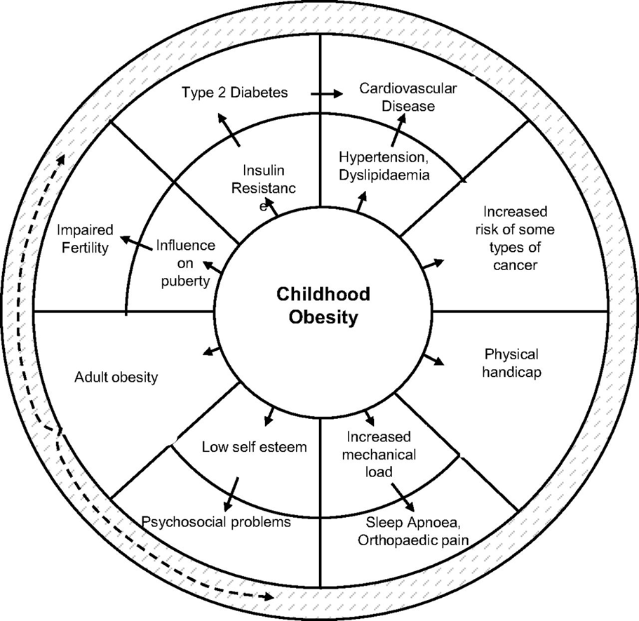

|  |
| --- |
| Comorbidities of childhood obesity are depicted in the outer ring with their intermediate processes in the inner ring. Childhood obesity, which in turn increases the likelihood of those comorbidities. |

**SUMMERY OF COMPLICATION OF OBESITY**

* High blood pressure
* Type 2 diabetes
* High cholesterol levels
* Asthma
* Development problems in the feet
* Liver disease
* Sleep apnoea

**TREATMENT & PREVENTION OF OBESITY**

**Obesity is a major health challenge to Barnsley**

The management of overweight and obesity in children and adolescents requires a multidisciplinary, multi-phase approach, which includes dietary management, physical activity enhancement, restriction of sedentary behaviour, pharmacotherapy and bariatric surgery. A holistic approach to tackle the childhood obesity epidemic needs a collection of activities including influencing policy makers and legislation, mobilizing communities, restructuring organizational practices, establishing coalitions and networks, empowering providers, imparting community education as well as enriching and reinforcing individual awareness and skills. The implications of this global phenomenon on future generations will be serious unless appropriate action is taken.

Our national approach to tackling obesity includes engaging with a wide range of partners including businesses, health professionals and individuals. We have set national ambition for a downward trend in excess weight in children and have a well-developed and wide-ranging programme of actions.

Obesity rates in children are levelling off.

**The key initiatives for tackling obesity are:**

**1. Tier 3 Weight management service-Tel 01226737060**

**2. Be well Barnsley,BMI less 35 only-Tel 01226737060**

**3. The National Child Measurement Programme and School Sports Funding.**

**4. This is in addition to measures being taken by other Government Departments such as the School Food Plan. (doh 2014)**

There are a number of different treatments for obesity in children. However, no treatment will work on its own. You will need to make changes to the foods you and your child eat and the activities you do, as well as changing some of the behaviours of the whole family.

Depending on the age of your child, your GP may plan to help your child to lose weight. However, weight loss is not always recommended in children so he or she may advise that you help to maintain your child’s weight. Therefore, as your child grows taller, his or her BMI improves but their weight stays the same.

Your GP may refer your child to a paediatric dietitian (a specialist in children’s nutrition and health).

**SERVICES AVAILABLE AT BARNSLEY**

1. All health and social care professional have duties to promote good health and to implement the

measures advised by NICE for prevention of obesity in the community.

1. Some of the key initiatives are Tier 3 weight management and be well Barnsley.
2. The National Child Measurement Programme and School Sports Funding.
3. Barnsley’s Integrated weight management programme - Dietitian either direct through weight management service –details available on line and contact can be made via phone or e mail
4. Weight management clinic - see referral pathway
5. Special programmes are arranged for children with disability within Greenacre
6. Nutrition group has draft of nutrition policy for Barnsley which will be implemented soon
7. Healthy lifestyles promotion through 0-19 service (Health visitor and School Nursing) and BMBC Children Centre programme

9. Measures being taken by other Government Departments such as the School Food Plan. DH 2014

**Investigation of obesity:**

* Full lipid profile
* Hb1C
* LFT
* UEs
* Fasting insulin glucose level
* GTT-in some cases
* USS liver

**Self-help**

It’s important to make changes that the whole family can do, rather than asking your child to have a separate diet or to start ‘dieting’. This may mean changes to mealtimes and snacking habits, or starting activities that the whole family can do together. Lifestyle changes work best for your child when they are long term, permanent changes.

**The National Institute for Health and Clinical Excellence (NICE) recommends the following.**

* Include starchy foods in meals such as potatoes, bread, rice and pasta, choosing wholegrain varieties where possible.
* Eat plenty of fibre-rich foods, such as oats, beans, grains, fruit and vegetables, wholegrain bread, and brown rice and pasta.
* Eat at least five portions of a variety of fruit and vegetables each day.
* Eat a low-fat diet and don’t increase your fat and/or calorie intake.
* Eat as little as possible of fried foods, sweets which are high in added sugars and fat, and high-fat foods such as takeaway meals or fast food.
* Reduce the amount of sugary drinks you have, including fruit juices with added sugar, and drink more water.
* Watch the portion size of meals and snacks, and how often you’re eating.
* Eat regular meals, including breakfast, in a pleasant, sociable environment without distractions.
* You should eat with your child and make sure that everyone is eating the same food.
* Make enjoyable activities – walking, cycling, swimming and gardening – part of everyday life.
* Minimise sedentary activities, such as sitting for long periods of time watching television, at a computer or playing video games. Try to limit this to less than two hours a day or 14 hours a week.
* Encourage active play, for example, dancing and skipping.
* Be more active as a family, for example, walking and cycling to school and the shops, going to the park or swimming. Children over the age of five need to do at least 60 minutes of moderate to vigorous intensity physical activity every day. This can be one session of activity or a number of sessions of 10 minutes or more.
* Encourage your child to participate in sports or other active recreation, and make the most of opportunities for exercise at school.
* Never put your child on a weight-loss diet without getting advice, as this can affect his or her growth. Talk to your GP or a dietician if you have any concerns about your child's weight.
* Setting goals and giving rewards and praise (not food associated). You and your child should be aiming to make long-term changes to the foods you eat and the activities you do. This is so that your child will be able to manage his or her weight when they become an adult. However, choosing some smaller goals to begin with may help you to focus and succeed. Give your child praise and rewards for their success, but make sure these aren’t food-related. Instead, try rewarding them by doing an activity they enjoy.

**Medicines**

Only few patients may need medication

Orlistat should only be given to your child if he or she is over the age of 12, is very obese and has other health problems caused by their weight.

**Surgery**

Weight-loss surgery for children is rare. Surgery will only be suggested if other treatment failed

**Healthy diet**

A healthy diet contains plenty of fruit and vegetables; is based on starchy foods such as wholegrain bread, pasta and rice; and is low in fat (especially saturated fat), salt and sugar.

Specific dietary recommendations (UK)

(Population average intakes; apply to children aged 5 years and over)

* Total fat: maintain at 35% of food energy
* Saturated fat: reduce to 11% of food energy
* Added sugar: reduce to 11% of food energy
* Fibre: increase to 18 g/day
* Salt: reduce to no more than 6 g/day*
* Fruit and vegetables: increase consumption of a variety of fruit and vegetables to at least five portions per day
* Reduce sugary drinks and snacks.

**References**

1. Screening for obesity task force in children. Pediatrics.Jan, 18, 2010

1. Raja Lakshman and Ken K.Ong. Childhood obesity.Circulation.2012;126;1770-1779
2. Managing overweight and obesity among children and young people: life style weight

management service. October, 2013.NICE guideline (PH47)

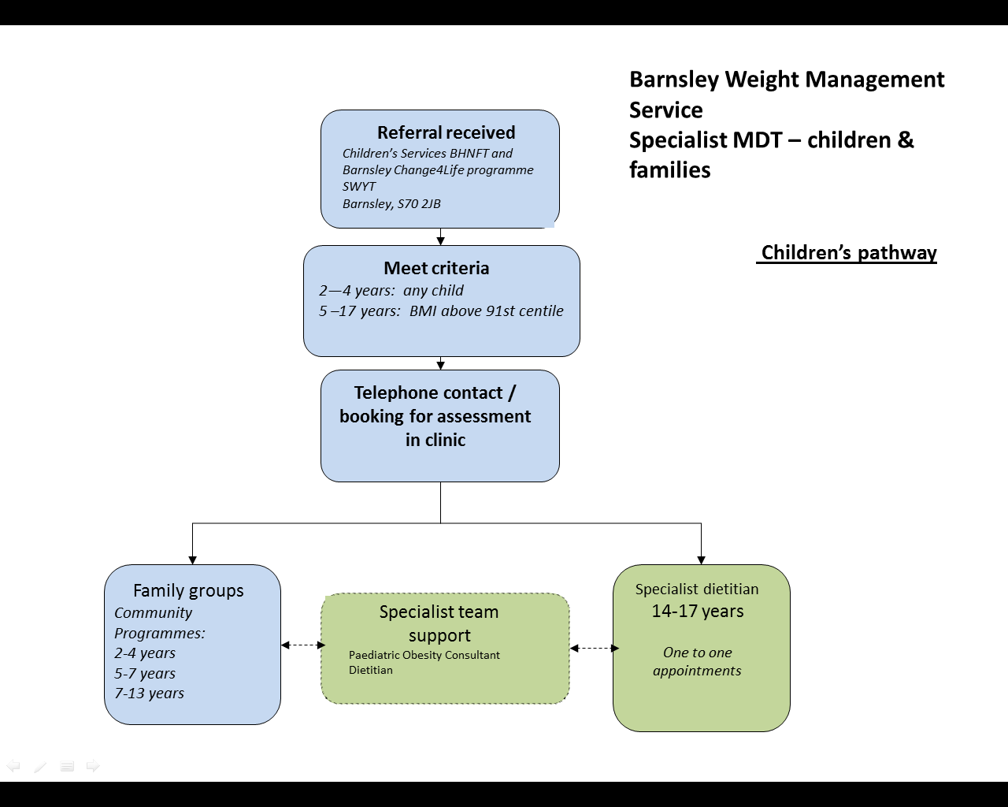

The clinic run by Dr Gupta

Phone to contact 012266737060

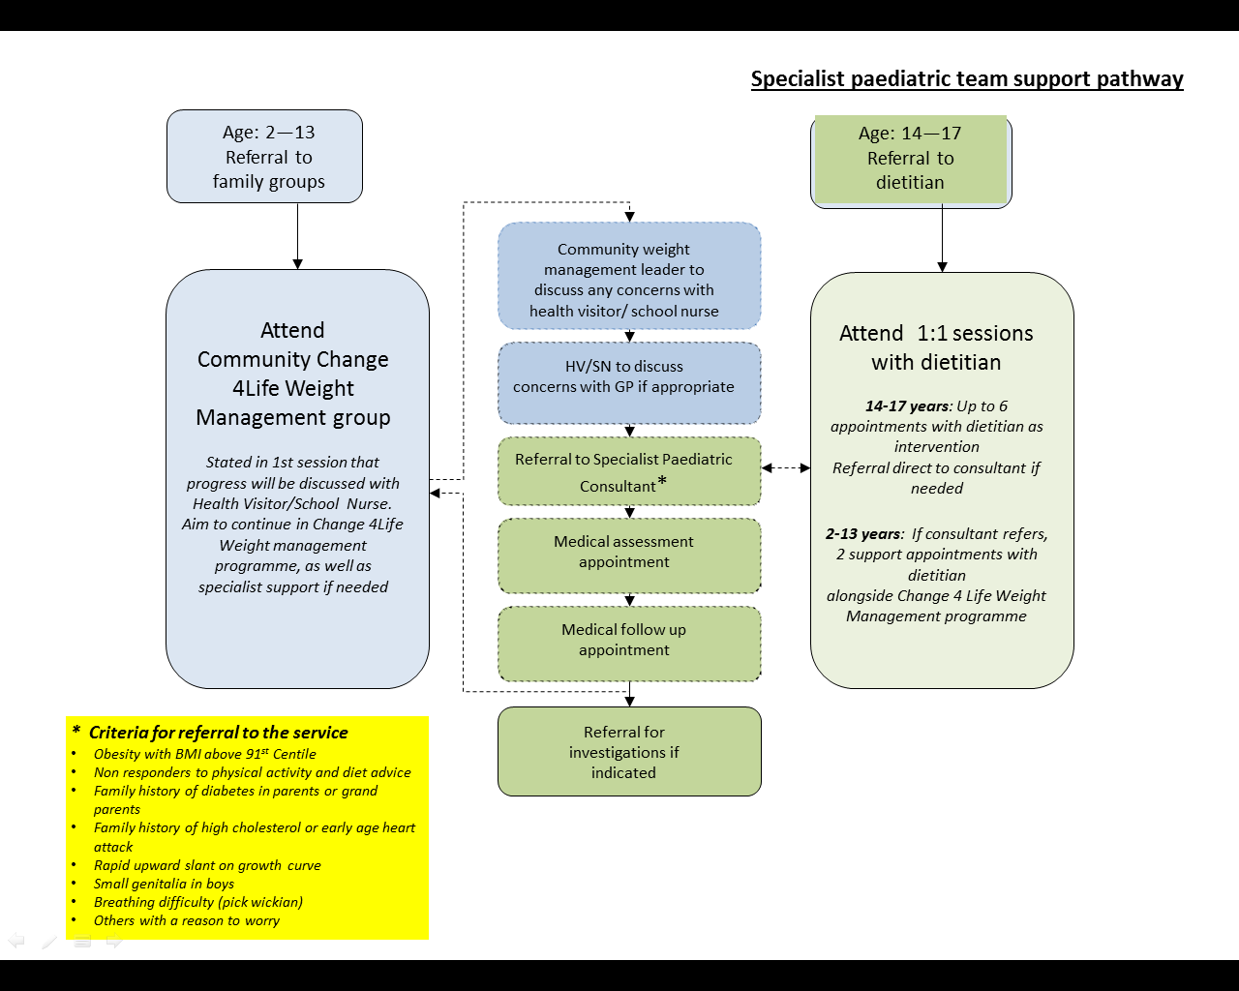

# GUIDELINES FOR DEVELOPMENTAL SCREENING/ASSESSMENT

**INTRODUCTION**

As many as 16% of children have developmental delay/or behavioural problems. However, only 30% are identified before school age.

A study in the UK (14) found that despite a system geared to detect subtle developmental disorders, the Child Health Surveillance failed to detect 38% of children with moderate learning disabilities and 94% of children with mild or moderate learning disabilities. Another study (15) on this matter shows a disappointing detection rate, failing to identify 55% to 65% of children with developmental problems before entry into school. If developmental delay is detected too late, opportunities for early intervention may be lost. These children will have missed the opportunity for early interventions .

One reason for low detection rate is high dependence on clinical surveillance. Alone, surveillance methods such as checklists and clinical observation have a poor sensitivity. Reports show that clinical judgement alone is inadequate and insensitive. One study revealed that physician impression would miss 45 % of children eligible for early intervention. Because children’s development is dynamic in nature, regular and repeated screening combined with surveillance is needed to detect developmental delays.

Recommendation from recent studies support the use of a validated screening tool at regular, repeated intervals, in addition to doctor’s surveillance, at all clinic visits.

**Definition of Development**

Changes follow an orderly pattern that moves toward greater complexity and enhance survival. It has four domains:

* Gross and fine motor skills
* Speech and language
* Social personal and activities of daily living
* Performance and cognition

**Definition of developmental Delay**

Developmental delay refers to circumstances when the child has not demonstrated a developmental skill by an age at which the majority of normally developing children have accomplished this task.

Developmental Delay can be divided into:

Global developmental delay– delay in two or more domains (often delayed in all domains)

Specific developmental delay– delay in a single domain (e.g. Motor or Speech & Language)

**Risk factors for developmental delay**

**Biological factors**

|  |  |
| --- | --- |
| **Antenatal risk factors** | Early maternal infection, such as Rubella, CMV, toxoplasma.  Late maternal infection, such as Varicella, Malaria, HIV  Toxins-alcohol ,smoke, pesticides, radiation  Drugs—for example, cytotoxic, antiepileptic’s  Genetic condition |
| **Perinatal risk factors** | Prematurity, LBW, Obstetric complication |
| **Neonatal factors** | Neonatal encephalopathy, Infection, severe hyperbilirubinaemia |
| **Postnatal factors** | Injuries, NAI, Meningitis, Encephalitis, FTT, severe epilepsy |
| **Other factors** | Visual and hearing losses and other specific learning difficulties |

**Environmental factors**

|  |
| --- |
| History of abuse or neglect  Inability to cope with the child’s needs - egg due learning disabilities  Maternal mental health disorders, most commonly depression  Severe under-stimulation, maltreatment, or domestic violence  Malnutrition, especially deficiency of iron, folate, and vitamin D |

**Identification of developmental problems**

1. Parental concern

2. Surveillance

3. Healthy Child Programme

4. Professional screening

5. Assessment and Evaluation

**Differences between surveillance and screening**

|  |  |
| --- | --- |
| **Surveillance** | **Screening** |
| The process of recognised children who are at risk of developmental delay. | Use of standardised tool to identify a child at risk of a developmental delay or disorder. |
| Observe child’s behaviour.  Parent discussion:-problems at home, concerns about child’s behaviour, health.  Health history and examination.  One reason for low detection rates.  Capture 30% of children’s problems.  Reports show that clinical judgment alone is inadequate and insensitive. | Identify problems or symptoms early in life.  Involve parents and focus on positive development.  Standardised screening instruments are more accurate than clinical impressions/ observations.  Include all children in the screening program.  Screening instruments are not diagnostic tools. |

**Aims of the Developmental Screening**

1. To develop and implement a model programme for children that includes their Developmental needs.

2. To help parents understand developmental milestones and behaviour that facilitates Healthy development.

3. To identify and respond to provide concerns about developmental screening.

4. To monitor and track the impact of implementing the ages and stages screening tools

5. To provide the appropriate intervention

**The evidence for early intervention (0—5)**

**Human brain development**

Neural connections for different functions develop sequentially

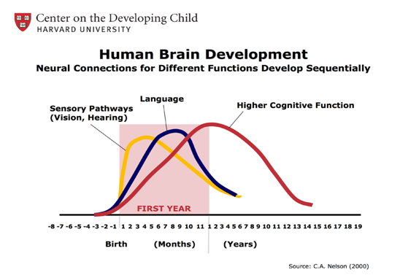

During the early months of life, the structure of the brain builds at a paralleled rate in response to nurturing experience.

Research shows that early intervention can greatly improve child’s development from birth to 5 and help in learning skills in aspect of development.

Early identification and intervention for children with developmental delay or disabilities can improve cognitive and social skills, lead to high achievement and greater independence and promote family competence and wellbeing.

**The Developmental Screening Tools**

There many screening tools but locally; two screening tools are used extensively.

|  |  |  |  |  |  |
| --- | --- | --- | --- | --- | --- |
| **Tool** | **Method** | **Age range** | **Outcome** | **Validation, sensitivity, specificity** | **Comments** |
| **ASQ3** | A parent reported questionnaire  It takes 10 -15 minutes to complete | 4-60/12 | Cut off point Guides needed for further assessment | Validated in large studies  Specificity ranges from 80% (16 months) to 92% (36 months, and 86% overall). Sensitivity average 72% | Easy to use. Parent report tool. gives a reliable and accurate results |
| **SGS2** | Professional scores items in 9 developmental fields; takes 15-20 minutes to complete | 0-59/12 | Graphic profile of developmental age compared with chronological age; Guideline to professional judgment for the next action | Original data validation study showed specificity of 94%-100% and sensitivity of 44%-82.5 in different fields. Validation of revised schedule showed high reliability (Cronbach 0.91) |  |

The evidence for using ages and stages for full term and late preterm are very strong.

For Preterm including ex preterm there are also many studies which validate the ASQ tool from 18 months corrected age and above.

There are some evidence support the use of ASQ for preterm babies at one year (CA) of age, most studies support the use of screening and the regular assessment by clinician.

**Studies which support the use ASQ for preterm at 1 year corrected age**

|  |  |  |  |  |  |
| --- | --- | --- | --- | --- | --- |
| **Citation** | **Study Group** | **Study type** | **Outcome** | **Treatment/ Mean effect** | **Comments** |
| Paediatrics 2012, July | 124 and112 infants- ASQ at 12CA and 24 months and Bayley scale of infant development | Cross sectional study | Identification of developmental delay  At 12 months CA) and 24 months.  Validity using K coefficient, sensitivity and specificity | Developmental delay are not adequately identified at 12 CA | Additional measures are needed. |
| Paediatrics 2013 | 306 term and preterm children age 8,18 and 3o months |  | ASQ-2SD below the mean was delay development-Byplay 3- 1 or below SD | ASQ-3 adequate psychomotor properties (sensitivity 75% and 81 specificity, this is in modest agreement with ASQ—R0.56 | ASQ-recommended for routine use in screening low-risk children at age 8,18 and 30 months (CGA) |
| Paediatrics of Child Health.  2001  ASQ-follow up of ex -premature infants | 136 questionnaires (81% completed.  Preterm less than 31 weeks  27±1.7SD | Cross sectional | ASQ compared to formal psychometric assessment (Griffith mental development scale for 12 and 24 months.  Bailey mental development intelligence scale at 18 months. The cut of developmental delay is 1 SD.ASQ cut of used 2SD(USA data mean and SD) | ASQ result compared to psychometric assessment  ASQ; Senitivity 90% specificity 40 %. % of agreement79%.  ASQ overall score agreed with the psychometric assessment (67%) | The high negative predictive value supports the use of ASQ as screening tool in premature babies.  ASQ will need to be combined with other strategies as part of comprehensive follow up program for ex-preterm babies |

**CGA = corrected gestational age**

**Barnsley referral pathway for Developmental Screening/Assessment**

**Universal screening**

All babies will have a developmental screening at 6, 12, 24-30 and at 42 months of age .

**Use corrected age for preterm babies until the age of 2 years (CGA**)

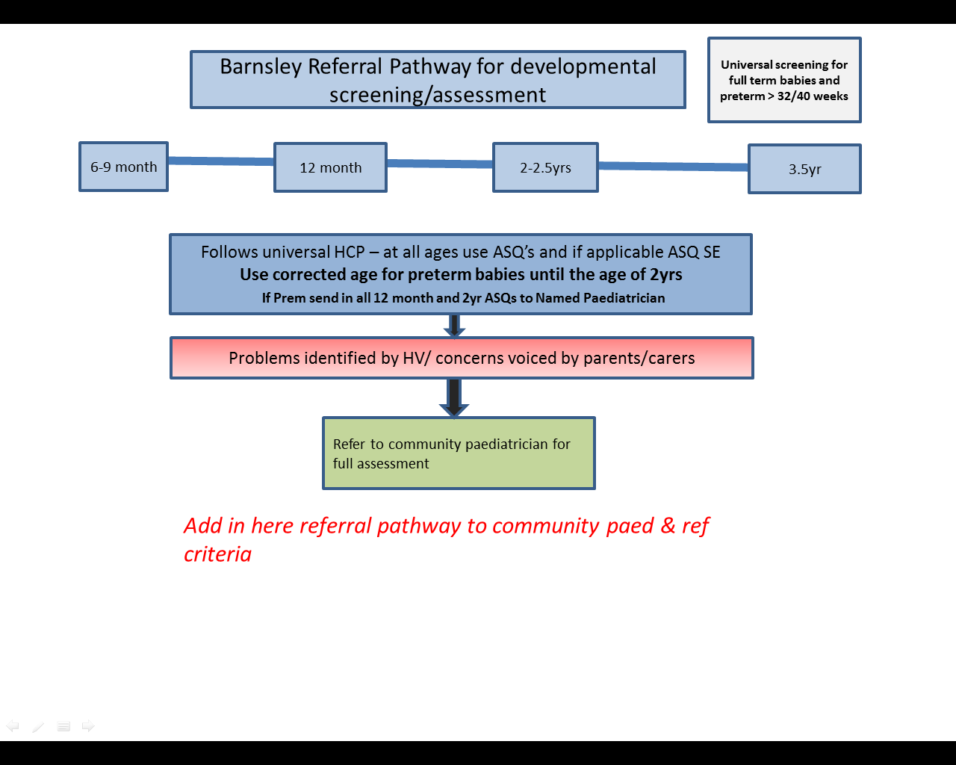

**See Appendix 3 &4**

**Babies at high risk of developmental delay** -

All babies at high risk should have 2 year outcome assessment (developmental screen and clinical assessment) . The result should be documented on Badger. This is recommended by the RCPCH, National Audit and NICE guidelines.

1. Babies < 32 weeks
2. Babies with birth weight < 1.5 kg
3. Hypoxic Ischaemic Encephalopathy(HIE)

**A**. Babies who have received therapeutic hypothermia for HIE

**B.** Babies who had moderate to severe encephalopathy who didn’t receive therapeutic hypothermia treatment eg . <36 weeks or the baby had postnatal collapse. The diagnosis of moderate or severe encephalopathy can be made using clinical scoring system and/or according to cerebral function changes if available (CFAM).

**Problems identified by HV at all stages**

Barnsley Referral Pathway for developmental screening/assessment

BABIES OF HIGH RISK OF DEVELOPMENTAL DELAY

Babies born <32 weeks

Babies with birth weight < 1.5kg

Babies born with HIE (Hypoxic Ischaemic Encephalopathy

**Notification from to be sent to HV after discharge from NICU**

Follow Universal HCP- At all ages use ASQ’s and if applicable ASQ SE

**Use corrected age for preterm babies until the age of 2 yrs.**

6-9 months

12 months

2 years

3.5 years

If baby was <36 weeks send completed 12 month ASQ (corrected age) to named paediatric consultant

HV completed ASQ (corrected age if prem) to be sent to named paediatric consultant

Full assessment to be completed by paediatrician at 2 yrs (corrected) and results inputted into clinical system (Badger)

**Refer to community paediatrician for full assessment**

**Referral to New Street for infant and children who failed developmental screening**

See appendix: Community Paediatric referral pathway for infants and children failed developmental assessment.

An action plan for children who fail the screening test should be started immediately before even the referral to professional team is made. This should according to their problems and needs according e.g. CAF if needed etc.

**Type of intervention for developmental delay**

1. Prevention (primacy prevention, secondary prevention and tertiary prevention)

2. Remediation - identify the needs and correct them

3. Compensation

**Early intervention services available**

The service provided should be tailored to child needs:-

* Audiology services
* Counselling and training for family
* Educational programmes
* Medical services
* Nutritional services
* Occupational therapy
* Physiotherapy
* Psychology/psychiatry services
* Respite services
* Speech and language
* Sure Start and Children’s Centre
* Family support services
* Other services

**Indicators of successful screening**

1. Fewer children will require special educational needs.

2. Improve IQ.

3. Decrease criminality.

4. Increase the chances of adult employment.

**Auditing results and monitoring outcome**

* Audit should be performed annually and results compared with other audits.
* All data should be electronically stored.

**Dr M Tumi-July 2016**

**References**

1. J Paediatric Child Health. 2001 Apr; 37(2):125-9.A parent-completed developmental questionnaire: follow up of ex-premature infants. Skellern CY, Rogers Y, and O’Callaghan MJ.

2. BMJ 2013; 346:e8687 doi: 10.1136/bmj.e8687 (Published 15 January 2013). Developmental screening - Martin Bellman Consultant Paediatrician1 &etal

3. American Family Physician 2011 Sep 1; 84. Paula S Mackrides &etal Screening for developmental delay

4. Paediatrics 2012, Jul; 130(1).Mimard MN &etal. Concurrent validity of ages and stages Questionnaires in preterm babies

5. Corrigan N, Stewart M, Scott M, Fee F. Predictive value of preschool surveillance in detecting learning disabilities. Arch Dis Child 1996;72:517–521.

6. Dearlove J, Kearney D. How good is general practice developmental screening? BMJ 1990;300:1177–1180.

7. The national audit programme (NNAP)

**Web sites useful for parents:-**

Contact a Family ([www.calmaily.org.uk](http://www.calmaily.org.uk)) A directory of Support Organisations for a wide range of disabling condition in childhood.

Mencap ([www.mencap.org.uk](http://www.mencap.org.uk))

Department of Education ([www.education.gov.uk/standard/earlysupport/page1](http://www.education.gov.uk/standard/earlysupport/page1))

Useful information for parents and carers regarding developmental delay and more specific diagnosis, such as Down syndrome

Appendix 1



Appendix 2

**Community Child Health Department - Referral Criteria.**

**The Community Child Health team will accept referrals from professionals working in all areas for the following:**

* Developmental delay in 2 or more domains (global developmental delay) once the child has been referred to other therapy services eg, speech and language, occupational therapy, physiotherapy, audiology.
* Children below the age of 5 years where there is concern around social communication or interaction or suspected autism spectrum disorder.
* Children 5 years and below with significant unexplained challenging behaviour or behavioural difficulties, once parents have agreed to and a place has been attained on a parenting course.
* Children with isolated speech and language delay will be accepted from speech and language therapists only, following an assessment and hearing test.
* Children with isolated fine or gross motor delay once they have been referred to the appropriate therapy service ie occupational or physiotherapy.
* Children with suspected or diagnosed genetic abnormalities or syndromes.
* Children and young people with daytime, secondary or refractory primary nocturnal enuresis. Referrals for refractory primary nocturnal enuresis will be accepted from the school nursing team only.
* Children with epilepsy.
* Children over the age of 12 months from hospital paediatricians, with predominant neurodevelopmental problems without on-going major medical needs for co-ordination of care and further management.
* Children under the age of 12 months from hospital paediatricians with neurodevelopmental problems without on-going major medical problems will be considered on a case by case basis. These children can be discussed at weekly Barnsley Child development team meetings (BCDT) at New Street HC on Tuesdays 12:15 to 1:00pm by the hospital paediatrician either in person or by prior arrangement by faxing the details to community paediatrics. Some children in this cohort will need shared care between community and hospital paediatric team.

**The team will no longer accept referrals for developmental assessments where there is no concern around development. If a referral is made for a developmental assessment by a hospital paediatrician the team will no longer arrange to review the child following the assessment.**

Appendix 3

# Community Child Health (Community Paediatrics) Referral Form

Please complete this form for all referrals to community child health. Complete pages 1,2 & 3 identifying the reason(s) for referral by ticking the box(es) of the appropriate referral criteria. Then complete the additional information page and the appropriate corresponding section(s).

Please note that referrals made for reasons other than those included in the criteria identified below will not be accepted by the department.

Also, please consider that if a child is being referred into this service they should ideally have a Common Assessment Framework (CAF) or Early Help Assessment (EHA) in place or be in the process of having one completed.

**Health Visitors –** Please enclose any up to date ASQ assessments.

**Doctors, Allied Health Professionals and Schools,** please attach an up to date summary or report**.**

|  |  |  |  |  |
| --- | --- | --- | --- | --- |
| **Name of Child** | | | **Date of Birth** | |
| **Age** | **Male / Female** | | | **NHS No** |
| **Address**  **Postcode** | | | | **Tel no:** |
| **Name & address of GP** | | | | **Tel no:** |
| **Name of Health Visitor / School Nurse** | | | | |
| **Parent/s or Carer/s full names** | | | | |
| **Who has parental responsibility?**  **□ Parents**  **□ Other (please specify)** | | | | |
| **Ethnic Group preferred language** | | | | |
| **Nursery / School name and address** | | | | |
| **Referrer’s signature** | | **Name and designation of referrer** | | |
| **Date** | | **Tel no:** | | |

|  |  |  |
| --- | --- | --- |
| **CAF/EHA number:** | **CAF/EHA being completed:** | **CAF/EHA declined:** |

**Reason for Referral:**

* Developmental delay in 2 or more domains (global developmental delay). **Complete section 1.**
* Child below the age of 5 years where there is concern around social communication or interaction or suspected autism spectrum disorder. **Complete section 2.**
* Child 5 years and below with significant unexplained challenging behaviour or behavioural difficulties, once parents have agreed to and a place has been attained on a parenting course. **Complete section 3.**
* Child with isolated speech and language delay from speech and language therapists only, following an assessment and hearing test. **Complete section 4.**
* Child with isolated fine or gross motor delay (if medical cause is suspected) once they have been referred to the appropriate therapy service ie occupational or physiotherapy. **Complete section 5.**
* Child with suspected or diagnosed genetic abnormalities or syndromes. **Complete section 6.**
* Child or young person with daytime, secondary or refractory primary nocturnal enuresis. Referrals for refractory primary nocturnal enuresis will be accepted from the school nursing team only. **Complete section 7**.
* Child with epilepsy. **Complete reason for referral section on page 3 if required.**
* Child over the age of 12 months from hospital paediatricians for co-ordination of care and further management. **Complete section 8**. Children can be discussed under the age of 12 months of age on a case by case basis and a CDC clinic handover arranged.

|  |
| --- |
| **Reason for Referral:**  Please outline your reasons for referral in more detail if this is not included in your attached reports (use additional sheets if required): |
| **Additional documents enclosed with this referral form:**  (Please list all documents enclosed) |

|  |  |
| --- | --- |
| **Section 1**  Developmental delay in 2 or more domains: (global developmental delay) will be accepted once the child has been referred to appropriate therapy services.  Identify delay below by circling the appropriate number and complete the relevant sections. | |
| **1. Speech & language delay - Date referred to speech & language therapy:** |  |
| **2. Gross motor - Date referred to physiotherapy:** |  |
| **3. Fine motor – Date referred to occupational therapy:** |  |
| **4. Sensory – Date referred to occupational therapy for sensory profile assessment (if child is functionally impaired):** |  |
| **5. Hearing – Date referred to audiology:** |  |
| **6. Social interaction – If in a setting, nursery or school – date referred to communication and interaction team:** |  |
| **7. Visual – Date referred to ophthalmology:** |  |
| **8. If child is under 5 years of age and is not in a setting or nursery – Date referred to portage:** |  |
| **Other services/professionals involved:** |  |

|  |  |
| --- | --- |
| **Section 2**  Child below the age of 5 years where there is concern around social communication or interaction or suspected autism spectrum disorder.  Identify criteria below by circling the appropriate number and complete the relevant sections. | |
| **1. Concerns around social communication – If in setting, nursery or school: date referred to communication and interaction team:** |  |
| **2. Concerns around sensory issues – date referred to occupational therapy for sensory profile assessment (if child is functionally impaired)** |  |
| **3. Concerns around speech delay/regression – date referred to speech and language therapy:** |  |
| **4. Concerns around obsessions.** |  |
| **5. Concerns around rigid routinised behaviours.** |  |
| **6. Concerns about child’s behaviour.** |  |
| **Other services/professionals involved:** |  |

|  |  |
| --- | --- |
| **Section 3**  Child below the age of 5 years with significant unexplained challenging behaviour or behavioural difficulties, once parents have agreed to and a place has been attained on a parenting course.  Identify criteria below by circling the appropriate number and complete the relevant sections. | |
| **1. Concerns re aggressive behaviour** |  |
| **2. Concerns re challenging behaviour** |  |
| **3. Concerns re other behavioural difficulties** |  |
| **Date parenting course attended:** |  |
| **OR Date a place has been attained on parenting course:** |  |
| **Other services/professionals involved:** |  |

|  |  |
| --- | --- |
| **Section 4**  Child with isolated speech and language delay - from speech and language therapists only, following an assessment and hearing test.  Identify criteria below by circling the appropriate number and complete the relevant sections. | |
| **Referred to speech and language therapy by:** |  |
| **Date referred to speech and language therapy:** |  |
| **Date referred to audiology:** |  |
| **Other services/professionals involved:** |  |

|  |  |
| --- | --- |
| **Section 5**  Child with isolated fine or gross motor delay (where medical cause is suspected). Identify criteria below by circling the appropriate number and complete the relevant sections. | |
| **1. Gross motor delay – date referred to physiotherapy:** |  |
| **2. Fine motor delay – date referred to occupational therapy:** |  |
| **Other services/professionals involved:** |  |

|  |  |
| --- | --- |
| **Section 6**  Child with suspected or diagnosed genetic abnormalities or syndromes.  Identify criteria below by circling the appropriate number and complete the relevant sections. | |
| **1. Diagnosis of genetic abnormality/syndrome.** | |
| **Diagnosis:** |  |
| **Diagnosed by (if known):** |  |
| **Date (if known):** |  |
| **2. Suspected genetic abnormality/syndrome:** | |
| **Reason for concern:** |  |
| **Other services/professionals involved:** |  |

|  |  |
| --- | --- |
| **Section 7**  Child or young person with daytime, secondary or refractory (resistant to treatment) primary nocturnal enuresis. Referrals for refractory primary nocturnal enuresis will be accepted from the school nursing team only.  Identify criteria below by circling the appropriate number and complete the relevant sections. | |
| **1. Daytime enuresis.** |  |
| **2. Secondary enuresis**     1. **daytime**   **b) nocturnal** |  |
| **3. Refractory primary nocturnal enuresis (from school nurses only)** |  |
| **Other services/professionals involved:** |  |

|  |  |
| --- | --- |
| **Section 8**  Child over the age of 12 months (or younger if discussed with a community paediatrician) from hospital paediatricians for co-ordination of care and further management. | |
| **1. Date discussed with community child health:** |  |
| **2. Date of CDC clinic:** |  |
| **Other services/professionals involved:** |  |

**Once completed please return your referral form to:**

Community Child Health referral panel, Community Child Health department, (Community Paediatrics) New Street Health Centre, Upper New Street, Barnsley, S70 1LP.

**FOR OFFICE USE ONLY**

|  |  |
| --- | --- |
| **DATE** |  |
| **Accepted for** |  |
| **Consultant:** |  |
| **Associate Specialist:** |  |
| **Speciality Doctor:** |  |
| **Neurodisability Nurse:** |  |
| **SpR:** |  |
| **Inappropriate referral:** |  |
| **Redirect to:** |  |
| **Additional reports required:** |  |
| **PRINT NAME / SIGNATURE** |  |

Appendix **5**