B.E.S.T Event
Wednesday 22nd January 2020 - 12.45pm to 5.00pm
The Griffin Suite, Shaw Lane Sports Club, Barnsley, S70 6HZ
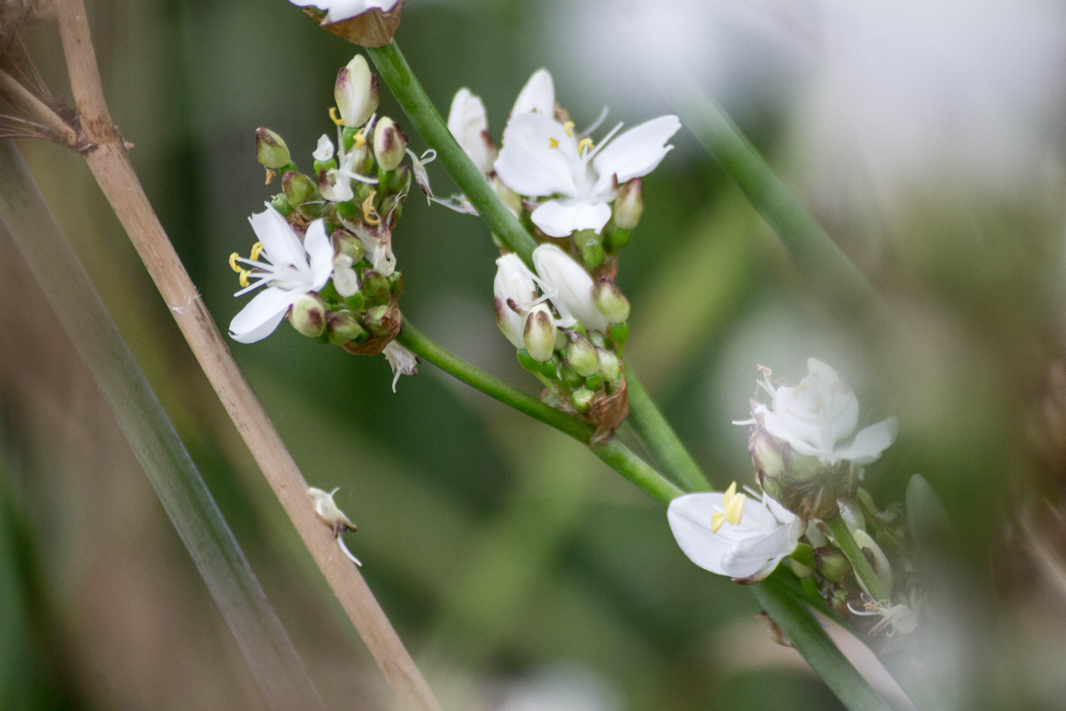

Movement Disorders and Parkinson’s
Mr Ajaz Khan, Consultant Neurologist, Sheffield Teaching Hospitals / BHNFT

Headaches
Dr James Ward, GP Partner Huddersfield

Neck Lumps
Mr Martin Wickham, Consultant ENT Surgeon BHNFT

Prevent
Ray Powell, Cohesion & Prevent Officer, BMBC

***Closing date for booking cover is Wednesday 8th January 2020***
If you have any queries please contact Michelle Thompson on 01226 433674 michelle.thompson26@nhs.net
GP B.E.S.T. Event & OOH/111 Booking Form

BEST EVENT

Wednesday 22nd January 2020

12.45pm – 5.00pm

Shaw Lane Sport Club, Barnsley, S70 6HZ

Name of Practice:

Practice Address:

Contact Email Address:

Contact Telephone Number:

Contact Name:

Please reserve place(s) for the following staff (list name(s) & designation of staff attending): -
Name: | State if GP, Practice Nurse, etc
Please indicate if buffet is required:  * If yes, please advise of any special dietary requirements: |  | Yes
 |  | No
Please indicate if OOH / 111 cover is required for your practice:  OOH / 111 cover may not be required if not all GPs from your practice are attending the event. |  | Yes
 |  | No

Notice to practice managers; If GP’s from your practice are booked and do not attend or leave early you will be charged for the out of hours cover.

**Closing date for booking – 8th January 2020**
Thank you for taking time to complete the booking form. Please email michelle.thompson26@nhs.net

