T2DAY PRACTICE SEARCHES 2025/26

BACKGROUND

A set of searches has been written to support the monitoring of activity for young patients with type 2 diabetes (T2DAY).

The searches show which patients have received key interventions and which patients have reached desired targets. The searches also identify the patients who haven’t had key interventions recorded or who are not currently being treated to target.

SYSTMONE INSTRUCTIONS

- The searches are located in SYICB Shared Resources > T2DAY > Practice searches
- Highlight all searches and click Run
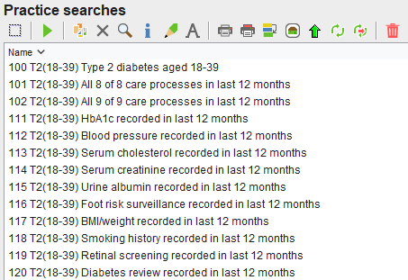
- Searches starting with 1 (e.g. 101) represent patients where the stated activity has been recorded or the target has been achieved. Searches starting with 2 (e.g. 201) represent patients where the stated activity has not been recorded or the target has not been achieved
- When the searches have completed, the usual range of clinical system functions will be available to use for reviewing records and contacting patients.

EMIS WEB INSTRUCTIONS

- The searches are available in the DIABETES > T2DAY > Practice searches folder. If this version of the searches is not present in the practice folder, it will need to be copied across from the Enterprise folder (BBS IT Services – Enterprise Search and Reports > […] Place | Report Library > Digital Transformation > DIABETES > T2DAY > Practice searches)
- Right-click on the Practice searches folder and click Run to run all searches in the folder
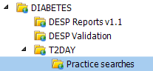 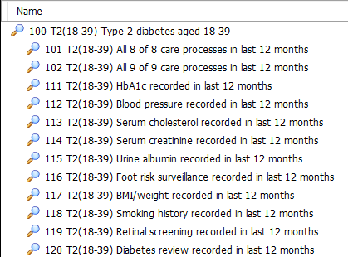
- Searches starting with 1 (e.g. 101) represent patients where the stated activity has been recorded or the target has been achieved. To see the patients where the activity has not been recorded or the target has not been achieved, use the Patients Excluded tab for the appropriate search.
- When the searches have completed, the usual range of clinical system functions will be available to use for reviewing records and contacting patients

OVERVIEW OF SEARCHES

100 T2(18-39) Type 2 diabetes aged 18-39
This search shows the current patients who have a type 2 diabetes code that is not superseded by a type 1 diabetes code or a diabetes resolved code.

101 T2(18-39) All 8 of 8 care processes in last 12 months
This search shows the patients who have 8 out of 8 care processes recorded in the preceding 12 months. The 8 care processes are defined as HbA1c, blood pressure, serum cholesterol, serum creatinine, urine albumin, foot risk surveillance, BMI/weight and smoking history.

102 T2(18-39) All 9 of 9 care processes in last 12 months
This search shows the patients who have 9 out of 9 care processes recorded in the preceding 12 months. The 9 care processes are defined as the 8 care processes in search 101 with the addition of retinal screening.

111 – 119 T2(18-39) [Individual care process] recorded in last 12 months
Searches 111 – 119 show the patients who have each of the 9 care processes recorded in the preceding 12 months.

120 T2(18-39) Diabetes review recorded in last 12 months
This search shows the patients who have a diabetes review recorded in the preceding 12 months.

121 T2(F18-39) Female patients
This search shows female patients aged 18-39 with type 2 diabetes and is used as the parent population for searches 122-123.

122 T2(18-39) Latest HbA1c<=48 recorded in last 12 months (female)
This search shows the female patients with most recent HbA1c<=48 recorded in the preceding 12 months.

123 T2(18-39) Latest HbA1c<=58 recorded in last 12 months (female)
This search shows the female patients with most recent HbA1c<=58 recorded in the preceding 12 months.

124 T2(F18-39) Male patients
This search shows male patients aged 18-39 with type 2 diabetes and is used as the parent population for searches 125-126.

125 T2(18-39) Latest HbA1c<=48 recorded in last 12 months (male)
This search shows the male patients with most recent HbA1c<=48 recorded in the preceding 12 months.

126 T2(18-39) Latest HbA1c<=58 recorded in last 12 months (male)
This search shows the male patients with most recent HbA1c<=58 recorded in the preceding 12 months.

131 T2(18-39) All three treatment targets met in last 12 months
This search shows the patients who have met all 3 treatment targets in the preceding 12 months. The 3 treatment targets are defined as latest HbA1c<=58, latest blood pressure <=140/80 and latest serum cholesterol <=5.

132 – 134 T2(18-39) [Individual treatment target] recorded in last 12 months
Searches 132 – 134 show the patients who have met each of the 3 treatment targets in the preceding 12 months.

141 T2(18-39) Structured education programme offered
This search shows the patients who have an offer of a diabetes structured education programme recorded.

142 T2(18-39) Structured education programme attended
This search shows the patients who have attendance at a diabetes structured education programme recorded.

151 T2(18-39) Currently pregnant
This search shows the female patients who have coded entries suggesting they are currently pregnant and is used as the parent population for searches 152-153.

152 T2(18-39) Currently pregnant with latest HbA1c<=48 recorded in last 12 months
This search shows the female patients who have coded entries suggesting they are currently pregnant with most recent HbA1c<=48 recorded in the preceding 12 months.

153 T2(18-39) Currently pregnant with folic acid 5mg issued in last 9 months
This search shows the female patients who have coded entries suggesting they are currently pregnant with folic acid 5mg issued in the preceding 9 months.

154 T2(18-39) Pre-conception advice recorded in last 12 months
This search shows all female patients who have pre-conception advice recorded in the preceding 12 months.

161 NoDM(18-39) At high risk of type 2 diabetes (pre-diabetes or latest HbA1c 42-47)
This search shows the patients without diabetes who either have pre-diabetes recorded or most recent HbA1c<=42-47 recorded in the preceding 12 months.

171 T2(18-39) Type 2 diabetes diagnosed in last 12 months
This search shows the patients whose earliest type 2 diabetes code was recorded in the preceding 12 months.

In SystmOne, the searches starting with 1 (e.g. 101) show patients where the activity has been recorded or the target has been met. The searches starting with 2 (e.g. 201) show patients where the activity has not been recorded or the target has not been met.

In EMIS, all search titles start with 1 (e.g. 101). Patients where the activity has been recorded or the target has been met are shown in the Patients Included tab. Patients where the activity has not been recorded or the target has not been met are shown in the Patients Excluded tab.

HELP AND SUPPORT

Queries about the reports and their intended use should be directed to the SYICB Diabetes Team [email address or contact details to be provided].

Queries about accessing and running the reports should be logged using the BBS IT Self-Service Portal:
https://servicedesk.sheffield.nhs.uk

