We would like to update you on referral pathways and criteria for the RightCare Integrated Single Point of Access, Neighbourhood Nursing and Urgent Community Response (Crisis Response) pathways.
Neighbourhood Teams Service update for referrers:
Single Point of Access, Urgent Community Response and Planned Nursing pathways.

We have been undertaking a significant amount of development work to enable us to deliver against our Neighbourhood Teams specification and national guidance around 2 hr crisis delivery in community.

Single Point of Access:
Tel: 01226 644575
Email: RightCareBarnsleyIntegratedSPA@swyt.nhs.uk
Open 8am – 8pm 7 days per week.
Outside of operational hours 8pm to 8am referrers can dial the same number and the system will divert the call to the Urgent Community Response service.

All referrals for the following services are now managed through our RightCare Barnsley Integrated SPA:
- Neighbourhood Nursing including District Nursing, Community Matrons and Frailty Nurses (Referral form required)
- Palliative and End of Life Care
- Urgent Community Response (known previously as Rapid or Crisis Response)
- Breathe Respiratory Service (Referral form required with service inclusion/exclusion criteria)
- Long Covid Service
- Intermediate Care and Enduring (Domiciliary) Therapy
- Heart Failure Specialist Nursing Service (Referral form required with service inclusion/exclusion criteria)
- Specialist Continence Nursing Service (Referral form required with service inclusion/exclusion criteria)
- Cardiac and Pulmonary Rehabilitation (Referral form required with service inclusion/exclusion criteria)
- More specialist services will move into the SPA over the next six months, and we will let you know as this happens.

The SPA is made up of a team of nurses, SPA advisors and patient flow co-ordinators who undertake a number of functions including:
- Receipt and processing of community services referrals
- Single point of access for health and social care staff
- Care co-ordination and brokerage of the correct level of care. Nurses’ triage and advise on where a patient’s care is best delivered and, where appropriate, find alternatives to hospital admission, keeping patients at home where possible. If hospital is required, look at alternatives to ED, such as Same Day Emergency Care (SDECs).
- Managing patient flow across Health and Social care systems, looking at where there are blockages affecting delayed transfers of care and putting steps in place to improve this.
- Telephone support and advice to care homes.
- Gatekeepers for Intermediate Care bed-based elements and single point of access for Intermediate Care provision across partners.

8am-8pm working in Neighbourhood Nursing:
Planned nursing care, provided by our District and Neighbourhood Nurses is now provided 7 days a week between 8am – 8pm. If you wish to refer a patient to Neighbourhood Nursing, please see the attached referral proforma or phone the RightCare Integrated SPA (01226 644575).

Urgent Community Response Team (UCR): The team will aim to respond to crisis call outs 24/7 within 2 hours. The team compromises of urgent community response nurses, Advanced Nurse Practitioners, Community Matrons, Occupational Therapists, Physiotherapists and Health care assistants. From April 2023, we will be extending our therapy assessment provision to 8am-8pm for patients in a crisis (currently available 8-5pm).

If you wish to refer a patient to Urgent Community Response, please phone the RightCare Integrated SPA (01226 644575). Please note: Between 8pm – 8am this phone number is diverted directly to the Urgent Community Response team.

Conditions that the UCR team will respond to (not exhaustive):
- Falls: With no apparent serious injury, including to the head, back, hip or where able to rule out a fracture, and where there has been no loss of consciousness.
- Decompensation of frailty: A frailty related condition which may result in loss of strength, speed, energy, activity, muscle mass, resilience to minor health strains and subsequent loss of independence. Decompensation caused by a minor stressor event, such as a urinary tract infection (UTI), that can cause a sudden or disproportionate decline in function.
- Reduced function/reduced mobility.
- Palliative / End-of-life crisis support
- Urgent equipment provision
- Confusion/delirium *
- Urgent catheter care
- Urgent support for diabetes – Do the team currently provide this?
- Unpaid carer breakdown which, if not resolved, will result in a health care crisis.

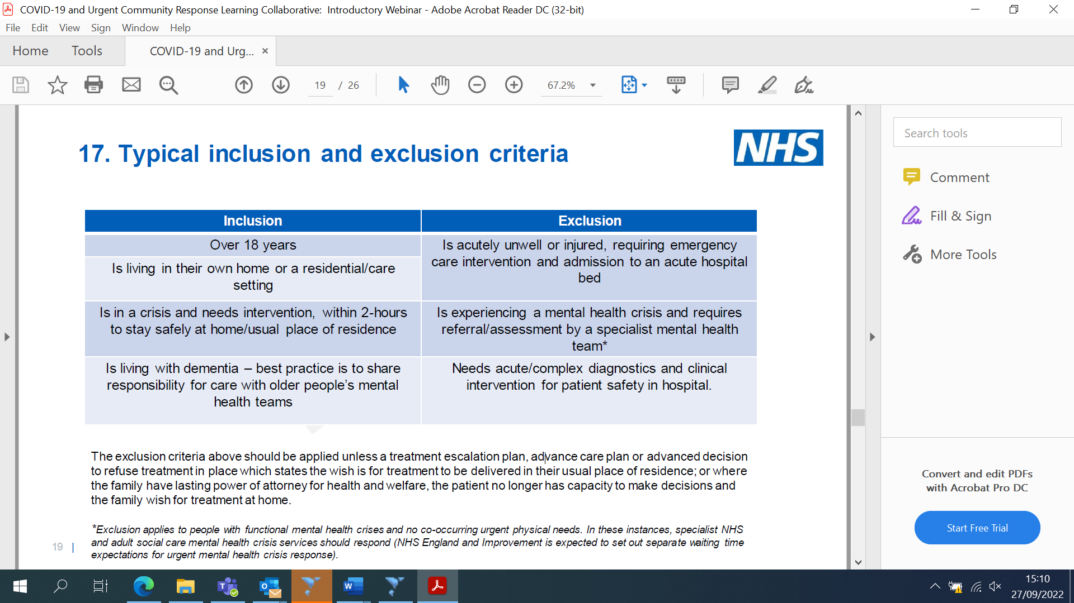

Urgent Community response also continue to support Out of Hours District Nursing work post 8pm.

IV infusion in Community:
Our Neighbourhood Nursing and Urgent Community Response teams continue to provide IV Outpatient Antimicrobial therapy for with several conditions including:
- Cellulitis
- Endocarditis
- Chest infections
- Diabetic foot ulcers
- Urinary tract infections
- Orthopaedic Infections
- Ear infections
- Other conditions in consultation with relevant clinical personal and consultant microbiologist.

We work closely with acute colleagues in supporting patients to remain at home whilst having their ongoing IV treatment.

We also continue to accept GP referral for treatment of cellulitis with IV Teicoplanin. Referrals for other conditions can be discussed on a case-by-case basis. Referral for IV treatment is processed via the RightCare Integrated SPA. See referral form and criteria as attached.

NEWS2:

In line with national guidance the NEWS (National Early Warning Score) template has been updated to NEWS2. Our SPA nurses and nursing teams have moved to using the NEWS2 template as part of their assessment processes for identifying deterioration in patients who they see within a community setting.

If you have any queries regarding these changes, please contact: rightcarebarnsleyintegratedspa@swyt.nhs.uk

