

**Peripheral Venepuncture**

**Using Standard-ANTT in a Community Care setting**

*for the ANTT Practice Framework see:* www.**antt**.org

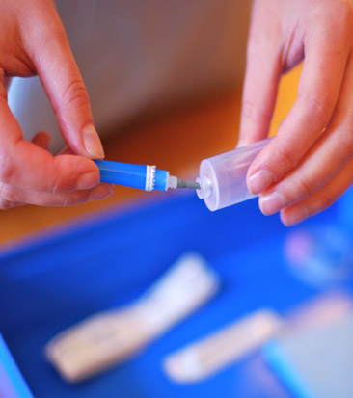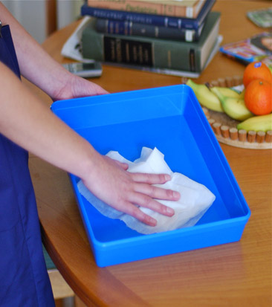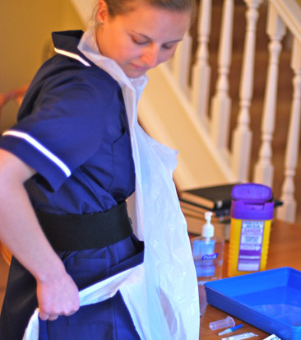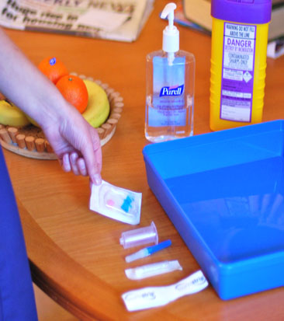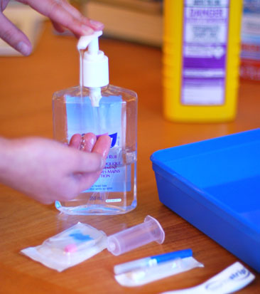

**5**

**4**

**3**

**2**

**1**

**4**

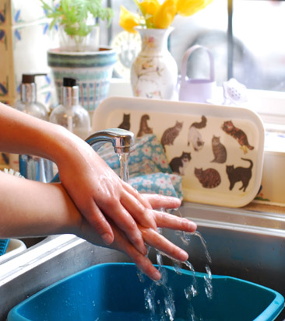

When entering the patient’s home

disinfect hands

**Gather Equipment**

& place around tray

**Prepare Equipment**

protecting **Key-Parts** with non-touch technique (NTT) & **Micro Critical Aseptic Fields**

**Disinfect Hands**

with alcohol hand rub

or soap & water

**Disinfect Tray**

as local policy – creating

a **General Aseptic Field**

**Apply Disposable Apron**

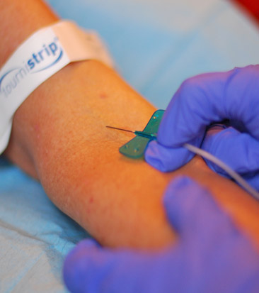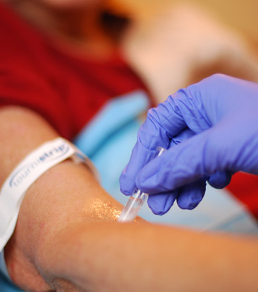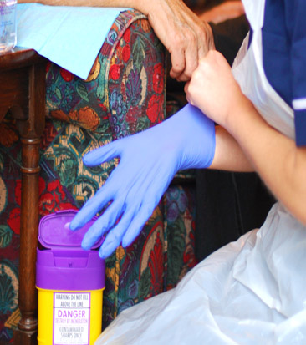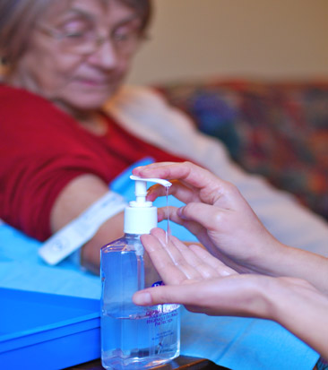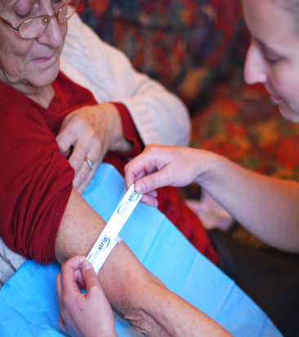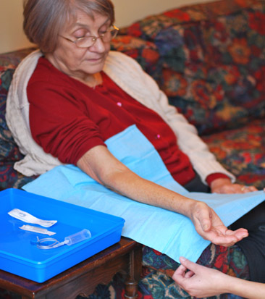

**11**

**6**

**9**

**7**

**10**

**8**

**If attempt to**

**draw blood is unsuccessful**

**return**

**to step**

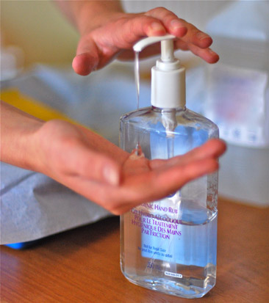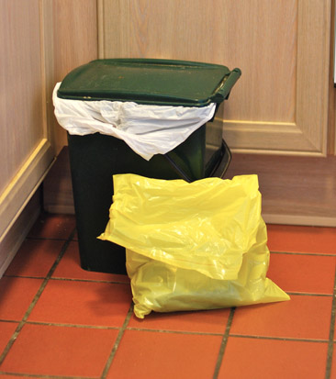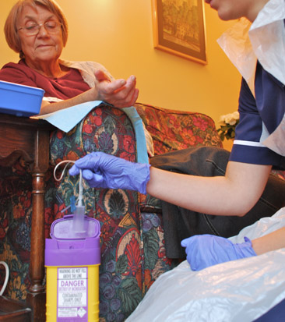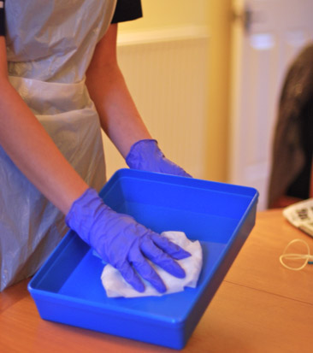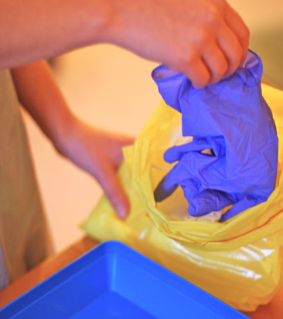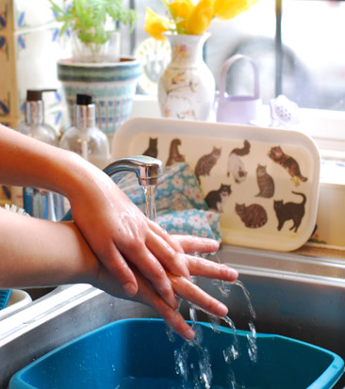

**Apply Tourniquet**

(use single-use disposable tourniquet) palpate

vein & release tourniquet

**Disinfect Skin**

with a 2% CHG / 70% IPA

using friction for 30 seconds.

Allow to dry

**Place Drape**

under thepatient’s arm

**Access Vein**

protecting **Key-Parts** &

**Key-Sites** using NTT

*If re-palpation needed, repeat step 10 or use sterile gloves***\***

**Apply Gloves**

(use sterile gloves if **Key-Site** must be touched directly)**\***

& re-apply tourniquet

**Disinfect Hands**

with alcohol hand rub

or soap & water

**12**

**15**

**16**

**7**

**Dispose of Sharps**

and equipment

**Disinfect Hands**

with alcohol hand rub

or soap & water

**Dispose of Waste**

according to local policy

When leaving the patient’s home

disinfect hands

**Your Organisation Logo Here**

**Dispose of Gloves**

then apron & immediately…

**Disinfect Tray**

according to local

policy

**13**

**14**

ANTT® © v4.0 Please note that local policy or equipment changes may be applied. For advice, please see enquiries@antt.org