 |  | BREAST  Urgent Suspected Cancer (USC) referral  Please refer via e-Referral Service
 | Please use separate children’s proforma for patients under 16

Patient details
Patient Name | ${firstname} ${surname}
Address | ${patientAddress}  ${postcode}
DOB | ${dob} | NHS No. | ${nhsNumber}
Home Tel. No. | ${home} | Gender | ${gender}
Mobile Tel. No. | ${mobile} | Ethnicity | ${ethnicity}
Preferred Tel. No. | ${preferredNumber} | Email Address | ${email}
Main Spoken Language | ${language} | Interpreter needed? | Yes No
Transport needed? | ${transportNeeded} | Patient agrees to telephone message being left? | Yes No
Communication requirements | Hard of hearing: Visually impaired:  Learning/mental difficulties: Dementia:  Has the patient capacity? Yes No  Communication difficulties other: (please specify)  ${communicationDifficultiesOther}
Safeguarding concerns? | ${safeguardingConcerns}
Date of Decision to Refer | ${createdDate}

Registered GP details
Practice Name | ${practiceName}
Registered GP | ${usualName} | Usual GP / Referring GP | ${referringClinical}
Registered GP  Address | ${practiceAddress}
Tel No. | ${main} | Fax No. | ${fax}
Email | ${gpEmail} | Practice Code | ${practiceCode}

Patient engagement
The patient has been informed that the reason for referral is to rule out or rule in Cancer.
Supporting information (USC leaflet) provided
The patient has been informed of the likely next pathway steps and the time in which they should be contacted?
The patient has confirmed that they are willing and available to be contacted and attend the hospital for appointments and tests within the required timeframes?
(and that this may include virtual or telephone consultations if appropriate)
Does the patient want a relative present at the appointment | Yes No
Patient or Carer Concerns/ Support Needs at the point of referral:
${carerConcernsOrSupportNeeds}

Type of referral
(please refer to symptoms box)
Breast Symptoms (to be seen within 2 weeks):
Urgent suspected cancer |  | Routine (Breast symptomatic) |  | Suspected or confirmed metastatic breast cancer
For Doncaster & Bassetlaw Patients Only: Do not use this referral form for a patient who has previously had confirmed breast cancer who is still under breast clinic review, who presents with a further lump or suspicious symptoms. Telephone 01302 642397 for Doncaster or 01909 572192 for Bassetlaw. The patient may also self-refer if still under follow up.

For Rotherham Patients Only: Do not use this referral form for a patient who has previously had confirmed breast cancer who is still under breast clinic review, who presents with a further lump or suspicious symptoms. Please contact the patients key worker telephone number available on the patient’s treatment summary.

For Barnsley Patients Only: Do not use this referral form for a patient who has previously had confirmed breast cancer who is still under breast clinic review, who presents with a further lump or suspicious symptoms please contact the Breast Care Nursing Team on 01226 432220 between 9:00 till 16:00 Mon to Fri.
Patient under 16 – Please refer to paediatrics
Please obtain CCG funding approval for cosmetic procedures before referral
Other reason for referral:
Family history only (Please refer to NICE CG 164 for referral Criteria) |  | Prosthetic Fitting Clinic only |  | Cosmetic/ Reconstruction only
Urgent Suspected Cancer  Please only use this box if you feel this patient is LIKELY to have Breast Cancer | Yes | Symptomatic  Cancer NOT suspected (seen within 2 weeks) | Yes
Discrete, hard lump ±fixation, ± skin tethering |  | Women aged <30 years with a lump persisting post period.  Rotherham ONLY Women aged <30 years with a lump – Please follow the Breast Lumps in young women pathway on ICE
30 years and older with an unexplained breast lump with or without pain. |  | Patients with breast pain alone (no palpable abnormality) Please don’t refer until tried primary care management as cancer extremely unlikely (4-6 weeks regular NSAIDs or paracetamol as a minimum – see Best Practice Guidance). Antibiotics have no role in the management of breast pain without other sign of infection.  FOR SHEFFIELD PATIENTS with BREAST PAIN ONLY please refer to your local breast pain clinic via the Breast Pain Referral form.  FOR DONCASTER PATIENTS with BREAST PAIN ONLY please refer to your local breast pain clinic at STH via the Breast Pain Referral form.  Please Follow Pathway for Management and Investigation of Mastalgia (Appendix 1)
With spontaneous unilateral bloody or blood stained nipple discharge which stains clothes |  | Asymmetrical nodularity or thickening that persists at review after menstruation
With nipple retraction or distortion of recent onset (<3 months onset) |  | Infection or inflammation that fails to respond to antibiotics
Skin distortion/ tethering/ ulceration/ Peau d’orange |  | With unilateral eczematous skin of areola or nipple: please don’t refer until tried topical treatment such as steroid cream for 2 weeks
Unexplained lump in axilla. |  | Unilateral, spontaneous nipple discharge that is persistent or troubling
Male breast lump where cancer is suspected  Please Follow Pathway for Management and Investigation of Gynaecomastia (Appendix 2) |  | Male Gynaecomastia  Please Follow Pathway for Management and Investigation of Gynaecomastia (Appendix 2)
Patients using progesterone based contraception may not have a regular period but they have an ovulatory cycle so review at a different time in the cycle is valid
For pathway management and investigation of mastalgia guidance – See breast pain pathway (Page 4)
Please do not refer patients with dermatological problems such as moles or dermatitis of the breast skin

Location of symptoms
Please mark the breast diagram below by clicking where the symptom or lesion has been detected. You can mark the diagram more than once if required.

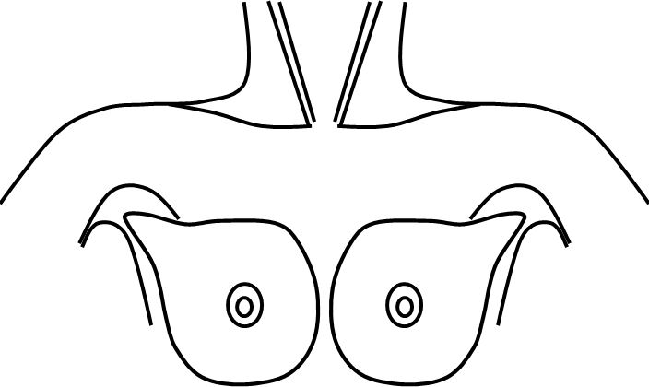

Please add clinical details and examination findings
(this can be copied from your consultation note)
${symptomsAndExaminationFindings}

Relevant investigations
${relevantInvestigations}
${mammographyG}

Performance status - WHO classification
0 - Able to carry out all normal activity without restriction
1 - Restricted in physically strenuous activity, but able to walk and do light work
2 - Able to walk and capable of all self-care, but unable to carry out any work. Up and about more than 50% of waking hours
3 - Capable of only limited self-care, confined to bed or chair more than 50% of waking hours
4 - Completely disabled. Cannot carry on any self-care. Totally confined to bed or chair

Consultations
${additionalClinicalInfo}

Past Medical History
${medicalHistory}

Family history
${relevantFamilyHistoryOfCancer}

Current Medications
${medication}

Allergies
${allergies}

To be completed by the Hospital Data Team
Date of decision to refer
Date of appointment
Date of earliest offered appointment (if different to above)
Specify reason if not seen at earliest offered appointment
Periods of unavailability
Booking number (UBRN)
Final diagnosis: Malignant Benign

Appendix 1 overleaf
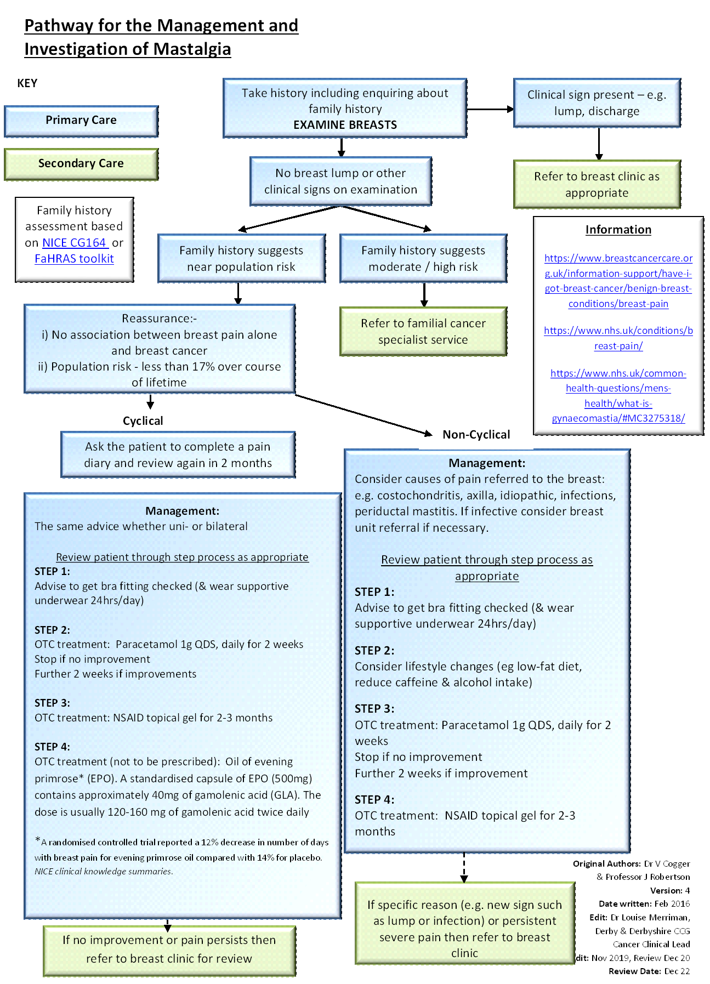s
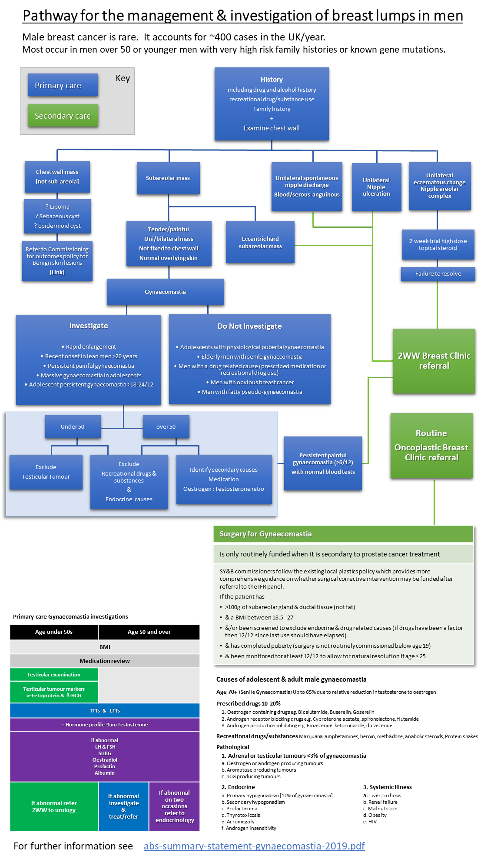
Appendix 2

Document Control
Version | Date | Author | Edit
Gynaecomastia Guidance | December 2020 | L. Caldon, | Development of Gynaecomastia guidance
4.1 | 28/01/2021 | L Horton, Julia Dicks, Kate Hodgkins | Lisa Caldon.  Addition of Gynaecomastia guidance and associated amendments
4.2 | 12/02/21 | L Horton | Amendment following CDG Feedback
4.3 | 01/03/21 | L Horton | Updated following input from Julia Dicks
4.4 | 04/03/21 | L Horton/ C Rogers | Minor changes following feedback from Primary Care
4.5 | 23/03/21 | L. Horton | Minor modifications following feedback of L Caldon.

Reviewers

This document has been reviewed by the following:
Name | Title / Responsibility | Date | Version
All Members | Breast CDG | 28/01/21 | V4.1
Julia Dicks | CDG Chair | 01/03/21 | V4.2
All Members | Breast CDG | 01/03/21 | V4.3
Julia Dicks | CDG Chair | 08/03/21 | V4.4
MDT Leads | Breast CDG | 09/03/21 | V4.4
Julia Dicks | CDG Chair | 23/03/21 | V4.5
Miles Payling | C the Signs | 01/06/2021 | V5.0
All members | Breast CDG | 17/1/2026 | V6.1

