The Heart Health Alliance is a multi-agency partnership focused on improving heart health outcomes in Barnsley and reducing inequalities through prevention, early detection and successful disease management. To share this work, quarterly newsletters will be produced to summarise discussions from each meeting.

Please can all Alliance members disseminate this letter across their local professional networks to raise awareness of heart health work, share opportunities and encourage collaboration, ideas and feedback.

The June 2023 Heart Health Alliance meeting focused on a review of progress of the Heart Health Alliance work so far.

Primary Prevention
Since the establishment of the Alliance, we have aimed to ensure there’s early prevention across all we do. Primary prevention is trying to promote healthy lifestyles and help people take ownership of their own health and wellbeing by making changes before ill health effects occur. This includes such things as stopping smoking, reducing alcohol, moving more and eating a healthy balanced diet. Each of these topics have been explored in relation to heart health at a Heart Health Alliance meeting and work has been undertaken to try and improve the support we offer in Barnsley. The presentation below has more details and suggests services to signpost people to for more support:

Service Discussion
Through the collaboration of the Heart Health Alliance we have been able to set up a variety of new services and programmes of work. The presentation above includes more details but so far we have:

- Funded several community heart health grants. We have funded Reds in the Community, Age UK and Dearne FC to provide heart health work to help us improve the heart health of our local population, often people who may not normally access health services. An example of the great work by Reds in the Community is below:
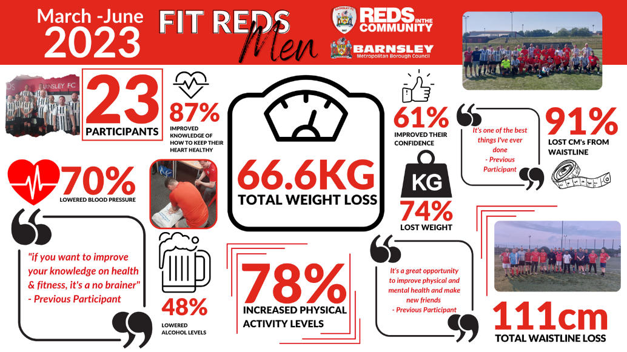

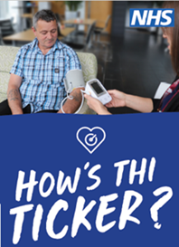
- Created the local community blood pressure service ‘How’s Thi Ticker’. As of June 2023 this has included:
  - Delivering 233 community sessions
  - Taking the BP of 3825 Barnsley residents
  - 30% of which were referred to the local pharmacy case finding service and 12% referred to their GP for further investigations and treatment.

- Sub groups – two sub groups have been set up to lead on specific pieces of work:
  - Heart Failure – looking at how we can improve the pathway for patients
  - Stroke prevention and early detection – creation of a new campaign across Barnsleyy to help people identify stroke symptoms and urging people to call 999 if they suspect a stroke. Watch this space for the campaign in the coming months.
- Stroke BP at home – building BP taking into the 6 week stroke review has seen great results and the team are sharing this best practice with other areas.
- NHS Health Checks – the precurement exercise is complete and the NHS Health Check service for all eligible people over 40 will begin August this year. It will be a targeted service to help the people most in need.
- Targeted Lung Health Checks – so far over 10,000 Barnsley patients have been invited for their lung health check. It has so far picked up several cancers and also heart health issues.

Priorities for next year and beyond

The group discussed the priorities of the Heart Health Alliance going forward. It was agreed that we will focus on:
- Building on the roll out of the How’s Thi Ticker campaign
- A targeted Stroke campaign
- Heart health prevention across the life course
- Evaluation
Whilst still being flexible and responding to local and national guidance.

Your feedback
We really welcome your thoughts on both the Heart Health Alliance meetings and this newsletter. If you have any feedback or suggestions please email to darminderkumar@barnsley.gov.uk

Next meeting:
Tuesday, 12 September 2023, 10:00am-12:00pm
Microsoft Teams

