The Heart Health Alliance is a multi-agency partnership focused on improving heart health outcomes in Barnsley and reducing inequalities through prevention, early detection and successful disease management. To share this work, quarterly newsletters will be produced to summarise discussions from each meeting.

Please can all Alliance members disseminate this letter across their local professional networks to raise awareness of heart health work, share opportunities and encourage collaboration, ideas and feedback.

The March 2023 Heart Health Alliance meeting focused on physical activity and stroke

Physical Activity
It is still a challenge to meet the national average for physical activity in the area - 9524 adults and 10,300 children need to be more active in Barnsley. Please take a look at the presentation to see some of the work that is happening:

Take a look at the local physical activity website to learn more, please also share with your teams and patients: https://www.barnsleywhatsyourmove.co.uk/

If you would like more info or to get more involved please contact: StuartRogers@barnsley.gov.uk

Barnsley Premier Leisure (BPL) offer to Barnsley residents a Wellbeing Programme and the Health Referral Scheme. See attached presentation for details of how to refer and what happens throughout the programme. Contact mark.goodhead@bpl.org.uk for more info.
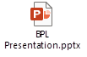

Reds in the Community offer 12-week health and wellbeing programmes for both men and women. https://barnsleyfccommunity.co.uk/health-2/ contact sean.margison@barnsleyfc.co.uk for more info.

Stroke
A Barnsley Stroke Task and Finish Group has been set up to create and lead a new campaign to raise awareness of early signs and symptoms of stroke and the importance of calling 999. The new campaign will use local insights to develop a campaign that resonates with Barnsley residents. Watch this space for the new campaign….coming soon.

Other news:

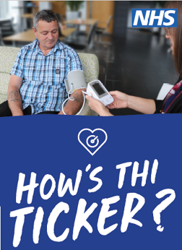
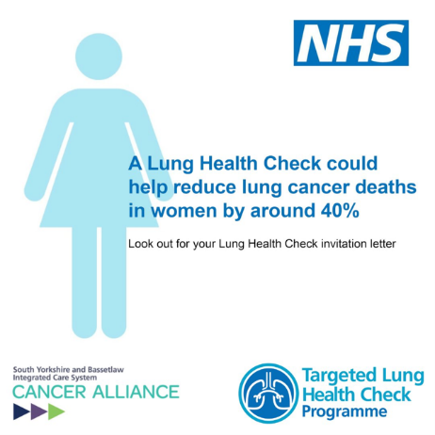
How’s Thi Ticker update – 3,482 people have had their BP taken so far over 212 sessions. 31% of people had a high reading and were referred to the local pharmacy case finding service for further investigation. Work is underway to develop the service to include key messages on stroke and irregular heartbeat.

Lung Health Checks
The lung health checks for Barnsley residents will commence 16th March with an official launch on 21st March.
People aged from 55 to 74 years, who smoke or used to smoke, and have a registered GP, will be offered a free NHS lung health check.

For more info visit: https://canceralliancesyb.co.uk/what-we-do/early-diagnosis/lung-health-checks#:~:text=From%20March%202023%2C%20people%20in,free%20NHS%20Lung%20Health%20Check or contact Siobhan.lendzionowski@nhs.net

More Money in your pocket website – local website for help and support during the cost-of-living crisis. On the page, you can find information about support with housing, utility bills, food and budgeting, as well as other support services such as help with mental health.
https://www.barnsley.gov.uk/services/advice-benefits-and-council-tax/help-with-the-rising-cost-of-living/

Next meeting:
Tuesday 6th June 2023, 10:00am-12:00pm
Microsoft Teams

