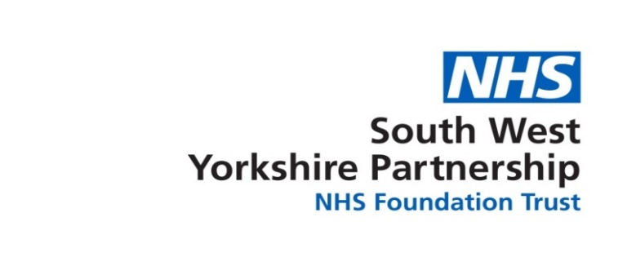
Neighbourhood Nursing Service Referral Form (Version 16/03/2023)

Date of referral……………………………………….

RightCare Barnsley Single Point of Access (01226 644575) is open 8am – 8pm, 7 days a week. Please complete all sections of the form.
PATIENT DETAILS  Name:  D.O.B:  NHS Number: |  | Address:  Post Code:  Home Tel. No.:  Mobile Tel. No:

REFERRED BY Name: Designation: Tel. No.:

WHICH SERVICE DO YOU REQUIRE?
District / Neighbourhood Nursing ☐ Community Matron ☐

MOBILITY (HOME VISITS WILL ONLY BE PROVIDED TO HOUSEBOUND PATIENTS)
Is this patient able to come to clinic? ☐ Is this patient housebound? ☐

VISIT REQUEST DETAILS (TIMESCALES)  Within 2 hrs ☐ Please ring the Single Point of Access on 01226 644575 to refer.  Within 24 hrs ☐  Within 72 hrs ☐  Within 7 days ☐  Over 7 days ☐  DATE VISIT(S) REQUIRED: Click or tap here to enter text. | ADDITIONAL INFORMATION  Does the patient have a history of violence and aggression? Yes ☐ No ☐  Any dogs in the property? Yes ☐ No ☐  Other key risks (e.g., social) Click or tap here to enter text.  Property access details (Key codes, parking etc) Click or tap here to enter text.
REASON FOR REFERRAL (Please also specify if the patient has any communication issues, is on the Learning disability register, has dementia etc.)
Click or tap here to enter text.
BLOOD SAMPLING REFERRALS ONLY (Please indicate who the results need to go back to)
Click or tap here to enter text.
INFORMATION RELEVANT TO THE REFERRAL (e.g., allergies / sensitivity, last three consultations, active problems, significant past medical history, acute / repeat medication)

Allergies / Sensitivity
Disabilities / Conditions
Latest BP
Active Problems
Last Three Consultations
Repeat Medications

