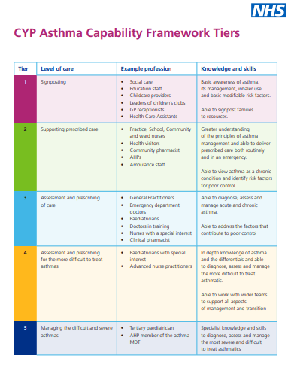
The National Capabilities Framework is for Professionals who care for Children and Young People with Asthma is aimed at anybody who may encounter a child or young person with asthma.
The framework is divided into 5 Tiers. A tier describes the level of care a person may be expected to deliver to a child or young person.
The tiers are not profession specific, but describe a level of asthma care an individual may deliver to a child or young person.
Individuals should look at their own role and choose the tier most appropriate to the care they deliver
Courses available: Asthma (Children and young people) - elearning for healthcare (e-lfh.org.uk)
A template portfolio can be downloaded CYP-Asthma-Tier-4-5-Professional-Development-Tool-Review.final-03032022.docx (live.com)

